Connect Link Pty Ltd

Network Design and Configuration Report

**Assessment 3 – TECH2100 Introduction to Information Networks**

Prepared BY: PRANIDHI Peiris

Student ID- 1853364  
Master Of Information Technology (Extension)

Subject Code – TECH2100

**TABLE OF CONTENTS**

1. **Overview  
    1.1 Company Background  
    1.2 Location and Infrastructure  
    1.3 Departmental and Floor Layout**
2. **Project Objectives**
3. **Design Choices  
    3.1 Network Model: TCP/IP  
    3.2 Hierarchical Network Design**
4. **Addressing Scheme**
5. **Configuration  
    5.1 VLAN Creation  
    5.2 Port Assignment  
    5.3 Trucking  
    5.4 Inter-VLAN Routing – Router-on-a-Stick  
    5.5 DHCP Configuration  
    5.6 Routing Protocols – OSPF**
6. **Network Security Measures**  **6.1 Port Security**

**6.2 SSH**  **6.3 Network Security measures**  **6.4 Quality of Service**

1. **Wireless Configuration  
    7.1 Access Point Setup  
    7.2 Wireless Device Connectivity**
2. **Troubleshooting Issues**
3. **Screenshots and Diagrams (Appendix)  
    - VLAN Configuration (Show VLAN Brief)  
    - DHCP Assignments on PCs, Printers, Wireless Devices  
    - OSPF Routing Tables  
    - Sub interface Configuration  
    - Trunk Link Status  
    - Ping Tests  
    - Port Security Violation Output  
    - SSH Remote Access Screenshots  
    - Wireless Configuration Screenshots  
    - Cisco Packet Tracer Topology**
4. **Knowledge Integration Summary**
5. **References**

1. Overview

**The telecommunications and logistics industry operates Connect Link Pty Ltd as a mid-sized enterprise that stays to develop. The main aim of Connect Link Pty Ltd efforts on enhancing transmission and delivery services via high-speed data solutions and supply chain efficiency.**

### Location and Infrastructure

**The HQ of Connect Link Pty Ltd engages three levels in a Melbourne industrial building located in Victoria. This has three individual floors which serve separate business operations to improve departmental attention and boost area productivity.**

Departmental and Floor Layout

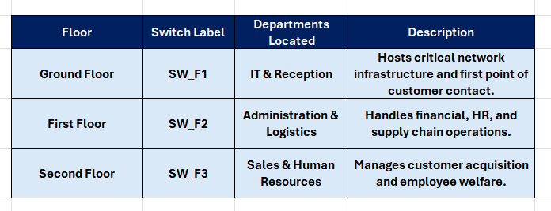

**The building structure with its multiple floors requires an adaptable network system which provides safe and flexible communication between departments and supports future company expansion.**

2. Project Objectives

**The primary objective of this project involves designing and testing a reliable and secure network for Connect Link through Cisco Packet Tracer which will also support future company growth. The project consists of multiple essential components which include departmental VLAN network creation and departmental communication setup with protection measures and DHCP IP address management and SSH router access security and port security device blocking and a simple layered network design for easy expansion or repair.**

**The three-floor Connect Link facility divides its space into separate departments which each use their own switch.**

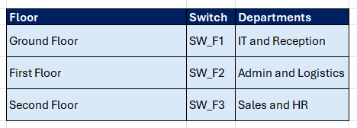

Each floor connects to a designated router:

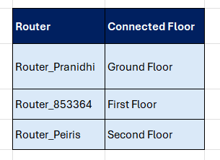

These routers handle **inter-VLAN routing** and external connectivity.

3. Design Choices

## 3.1 Network Model: TCP/IP

The **TCP/IP model** was chosen due to its dominance in real-world networking and its support for layered, interoperable communication.

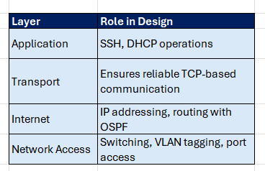

## 3.2 Hierarchical Network Design

A **three-tier hierarchical model** ensures scalability and clear fault isolation:

* **Core Layer**: High-speed interconnection between routers.
* **Distribution Layer**: Policy enforcement and VLAN routing.
* **Access Layer**: Connection point for user devices and APs.

This approach simplifies **troubleshooting**, **scaling**, and **policy enforcement**.

4. Addressing Scheme

A structured Class C private IP addressing plan improves network clarity and avoids overlap.

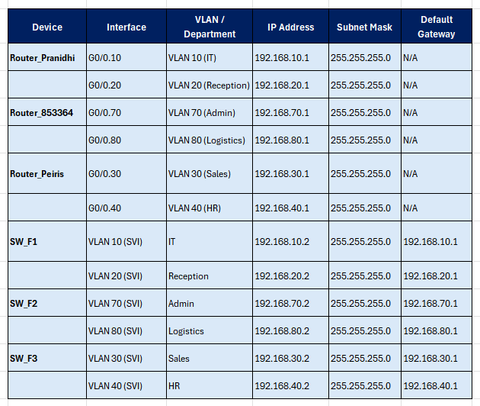

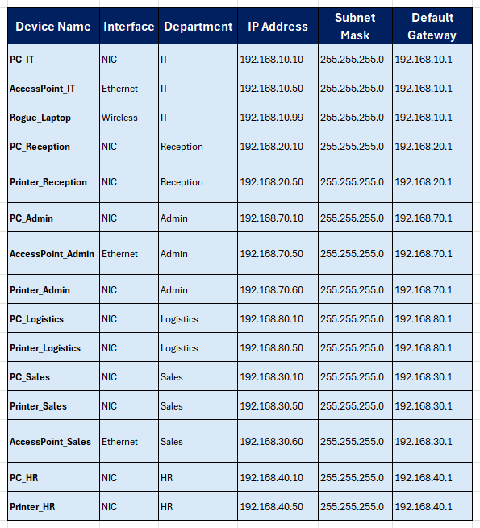  
Each VLAN uses a /24 subnet for ease of IP tracking and scalability within the department.

5. Configuration

**The multi-departmental organization Connect Link operates from three floors where IT Reception and Admin and Logistics and Sales and HR have their departments. Virtual LANs were implemented to create separate network domains which logically group different departments even though they exist on the same physical switch. This network design aims to enhance both performance and security and management capabilities.**

## 5.1 VLAN Creation

**All departments at Connect Link have their own dedicated VLAN.**

**The following VLAN assignments apply to each department:**

**• VLAN 10 – IT (located on Ground Floor)**

**• VLAN 20 – Reception (Ground Floor)**

**• VLAN 30 – Sales (Second Floor)**

**• VLAN 40 – HR (Second Floor)**

**The Admin department uses VLAN 70 while the Logistics department uses VLAN 80 to operate in the First Floor.**

**Each department exists as an independent entity within its VLAN because of this configuration which reduces broadcast traffic and improves security measures.**

**The implementation of VLANs for departmental isolation stops unauthorized broadcast traffic while also restricting inter-departmental access except through authorized channels which protects sensitive data of HR and Admin departments.**

## 5.2 Port Assignment

**The floor switches (SW_F1, SW_F2, SW_F3) have their VLAN assignments done manually by matching departmental ports to their respective VLANs. The PCs belonging to the IT department use switch ports that belong to VLAN 10 for their connection.**

**The exact port-to-VLAN assignment makes network device management easier through improved troubleshooting and decreased misconfiguration risks.**

## 5.3 Trunking

**The switches and routers exchange VLAN traffic through 802.1Q tagged trunk links. Devices that support multiple VLANs need trunk ports to transfer VLAN traffic.**

**The trucking system at Connect Link provides uninterrupted communication between floor-based switches and routers through a single link that does not require separate physical connections for each VLAN.**

## 5.4 Inter-VLAN Routing – Router-on-a-Stick at Connect Link

**The need for inter-VLAN communication between Sales and Admin systems for order processing operations requires the implementation of Router-on-a-Stick for inter-VLAN routing.**

**Each sub interface on the router corresponds to one VLAN. For instance:**

**The g0/0.10 interface functions as VLAN 10 (IT)**

**The g0/0.20 interface functions as VLAN 20 (Reception)**

**The single router interface at Connect Link functions as a cost-efficient solution for VLAN routing without needing separate physical connections for all VLANs.**

## 5.5 DHCP Configuration – Automated Addressing for Departments

**The DHCP system operates on the router to distribute IP addresses automatically throughout 6 department areas and all their floors.**

**The system operates using DHCP for network IP distribution through distinct pools that belong to VLANs.**

**• VLAN 10: 192.168.10.0/24**

**• VLAN 30: 192.168.30.0/24**

**The DHCP range contains static IP addresses (printers, servers, APs) to prevent network conflicts from happening.**

**The automated IP distribution system at Connect Link prevents device configuration mistakes because the organization employs numerous employees and multiple devices.**

## 5.6 Routing Protocols – OSPF for Internal Dynamic Routing

**The three routers named Router_Pranidhi Router_853364 and Router_Peiris operate OSPF because they serve different floors within the network. Fast and dynamic route updates become possible through network changes.**

**The scalability needs of Connect Link are supported by OSPF which automatically discovers and optimizes routes between routers and floors.**

6. Network Security Measures – Securing Connect Link's Network

## 6.1 Port Security

**The access ports of switches implement sticky MAC settings which restrict multiple devices from accessing each connection point. A new unauthorized device inserted into the network causes the port to automatically shut down.**

**Connect Link requires this security measure especially because its Reception area along with shared meeting rooms have network jacks that face the public.**

## 6.2 SSH Configuration

**The network devices at Routers use SSH instead of Telnet for encrypted remote administration which provides secure access for IT personnel or remote locations.**

**The IT staff at Connect Link requires network device access for troubleshooting operations as well as update procedures. The SSH protocol protects both credentials along with sessions from potential threats.**

## 6.3 Network Security Measures

**The network devices at Routers use SSH instead of Telnet for encrypted remote administration The network traffic will be controlled and unauthorized access will be prevented by using firewalls. VPNs will secure remote connections by encrypting data over public networks. These measures are essential for protecting the network and will be implemented in the next phase.**

## 6.4 Quality os services (qos)

**The network devices at Routers use SSH instead of Telnet for encrypted remote administration QoS will prioritize critical traffic like VoIP and video conferencing to reduce delays and packet loss. Traffic will be classified and managed on routers and switches to ensure smooth performance of time-sensitive applications.**

7. Wireless Configuration – Department-Based Secure Wireless Access

**The wireless network of Connect Link contains Access Points (APs) that function as follows:**

**The wireless network uses SSIDs which match department names (Sales_WiFi and HR_WiFi)**

**• WPA2 encryption**

**• Static IP within its VLAN**

**The network setup enables wireless devices to access the same VLANs which wireless and wired devices share for maintaining consistent access control and policy enforcement.**

**The staff requires wireless connectivity through their laptops along with tablets and mobile devices. The Connect Link system links APs to VLANs which provides both security measures and departmental isolation regardless of the wireless connection method.**

8. Troubleshooting Issues

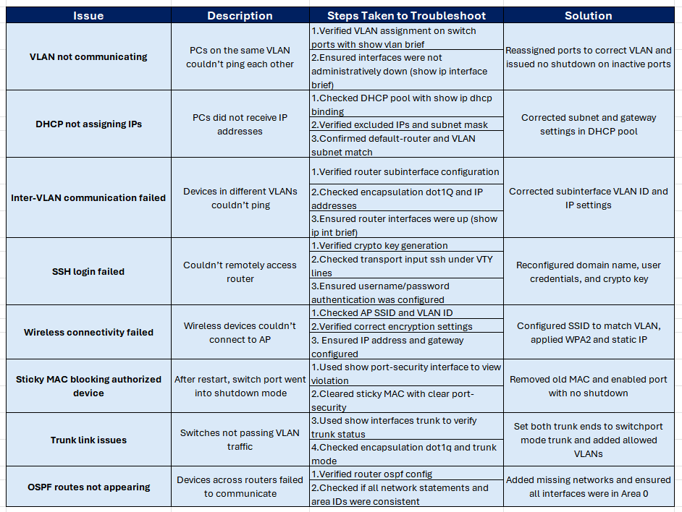

9. Screenshots and Diagrams (Appendix)

# VLAN summary (show vlan brief)

### Switch -SW_F1

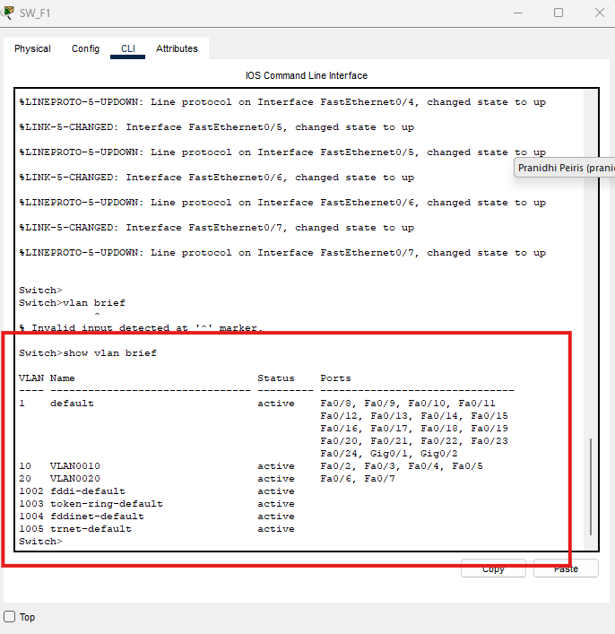

### Switch- SW_F2

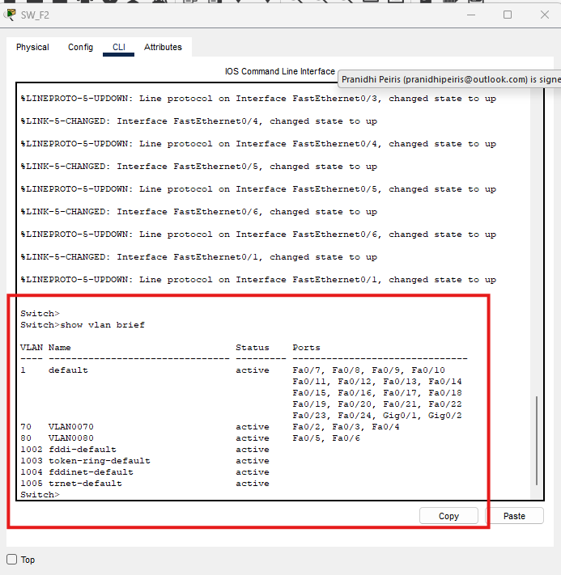

### Switch – SW_F3

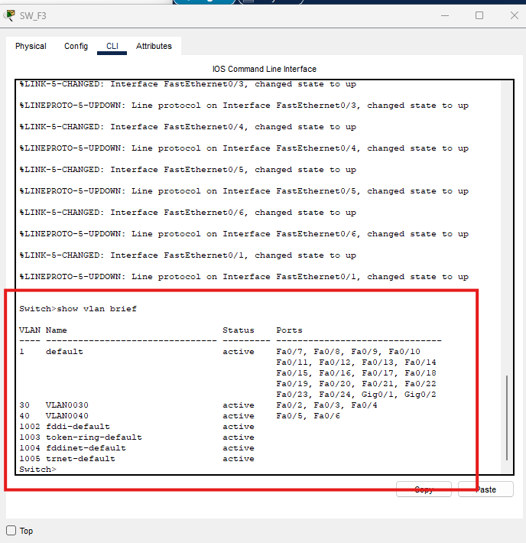

# DHCP assignment on PCs

### PC_IT

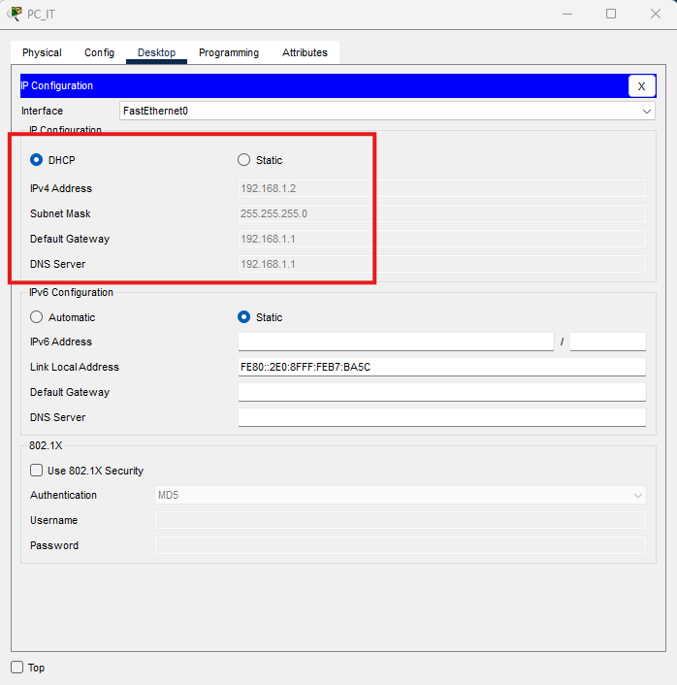

### PC_Admin

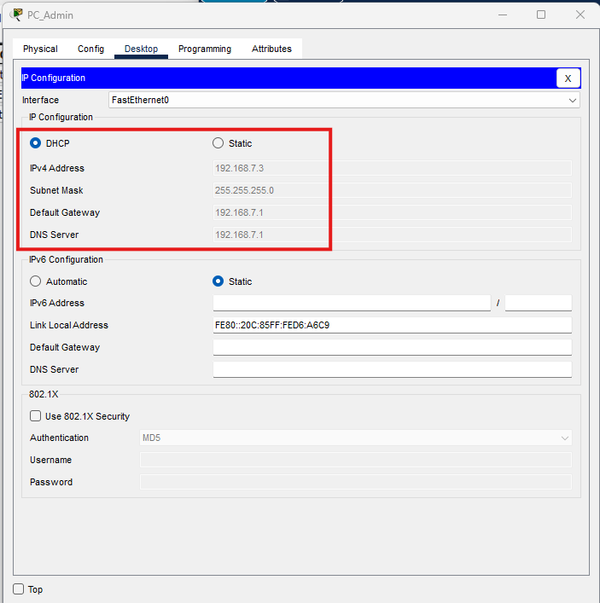

### PC_Reception

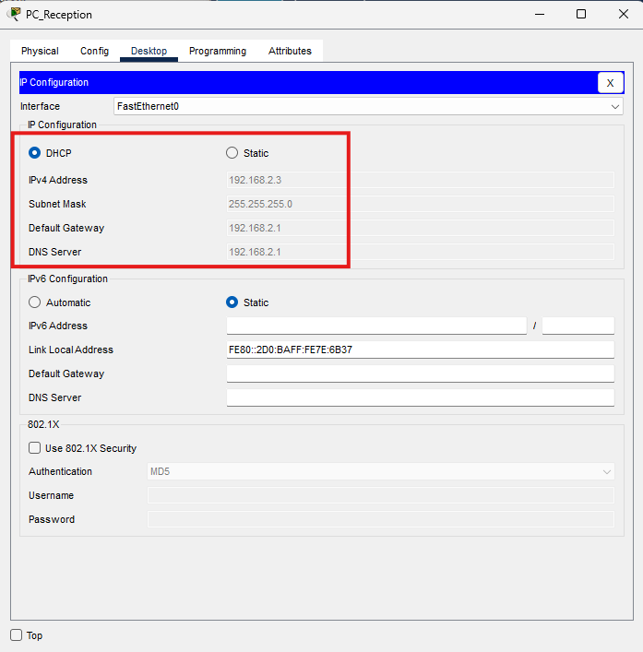

### PC_Logistics

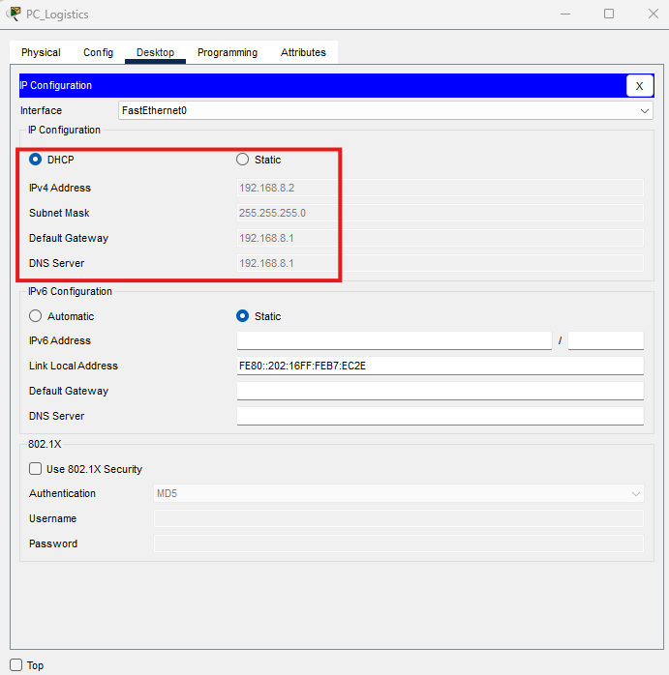

# DHCP assignment on Printers

### Printer_Reception

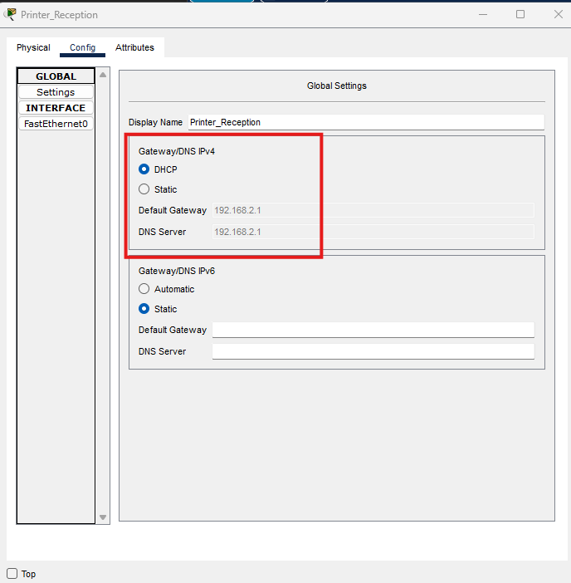

### Printer_Admin

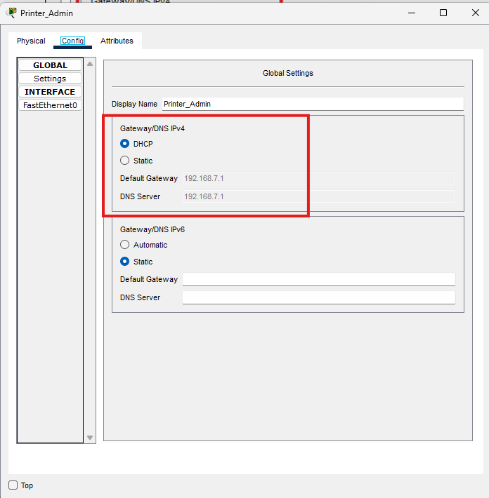

### Printer_Logistics

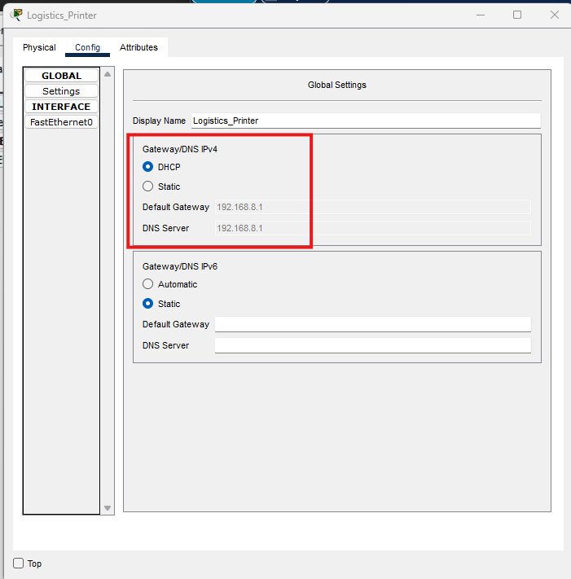

# DHCP assignment on Wireless Devices

### Tablet_Admin

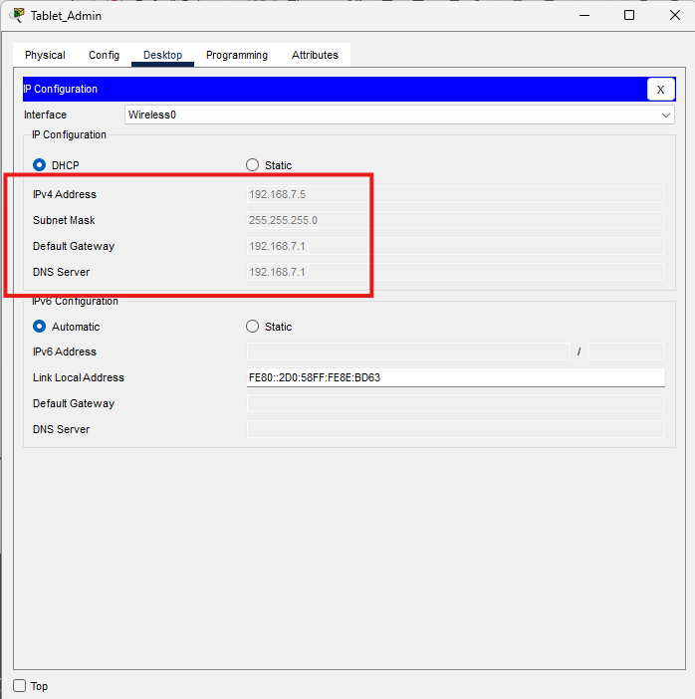

Smartphone_Staff  
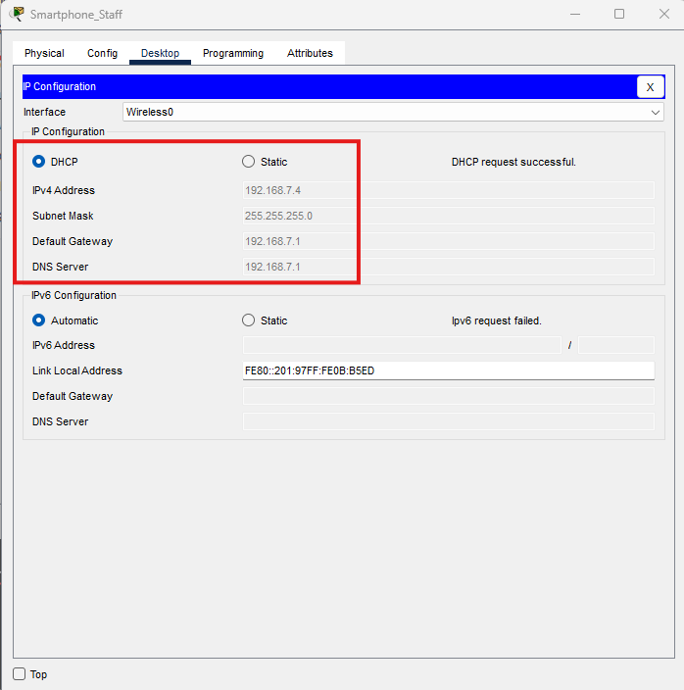

# DHCP assignment on Laptops

### Rogue_Laptop

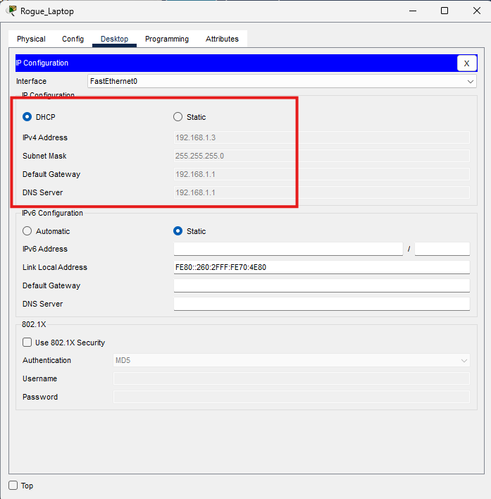

### Laptop_Staff

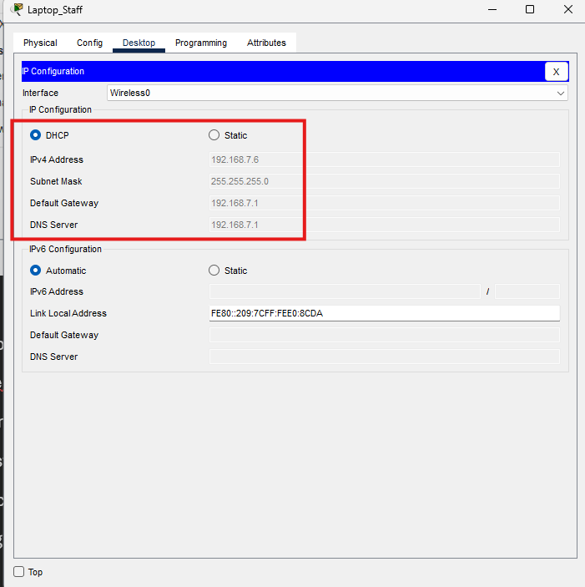

# OSPF routing table (show ip route)

### Router_1853364

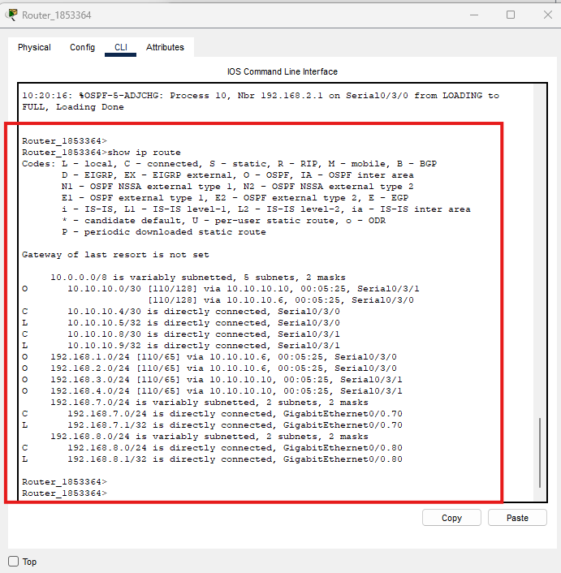

### Router_Pranidhi

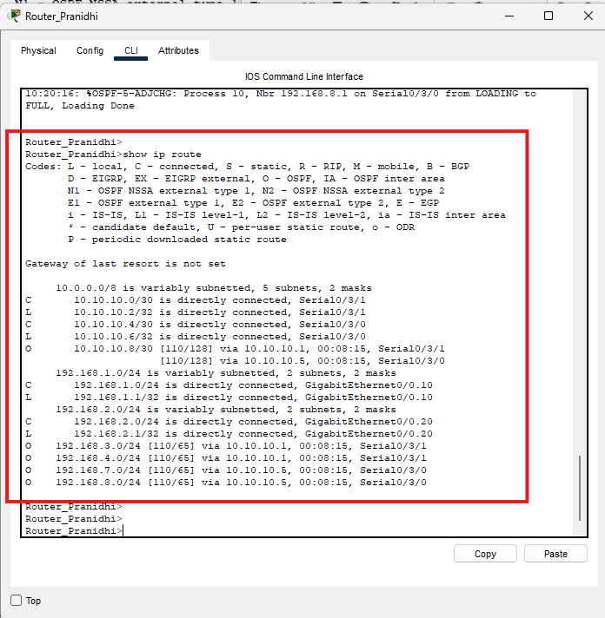

### Router_Peiris

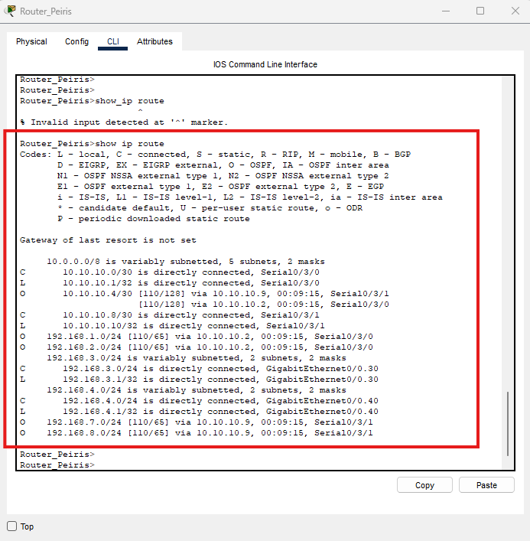

# Subinterface configuration on router

### Router_Pranidhi

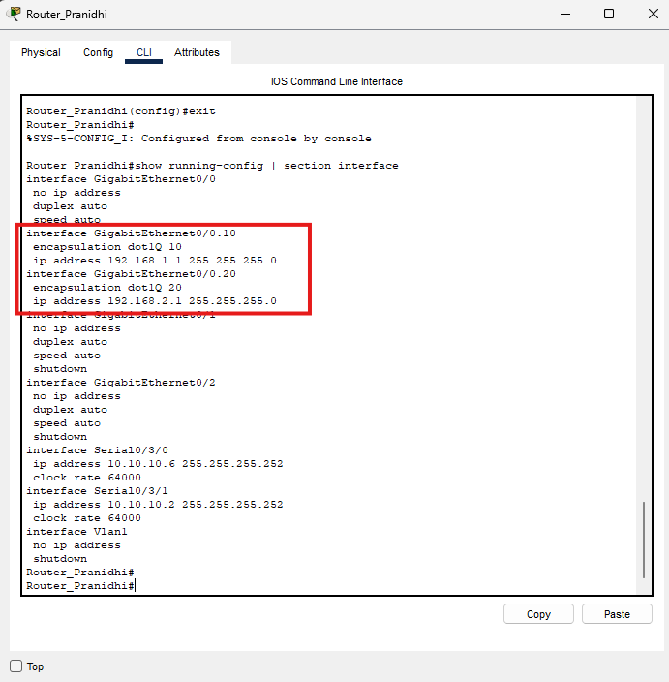

### Router_Peiris

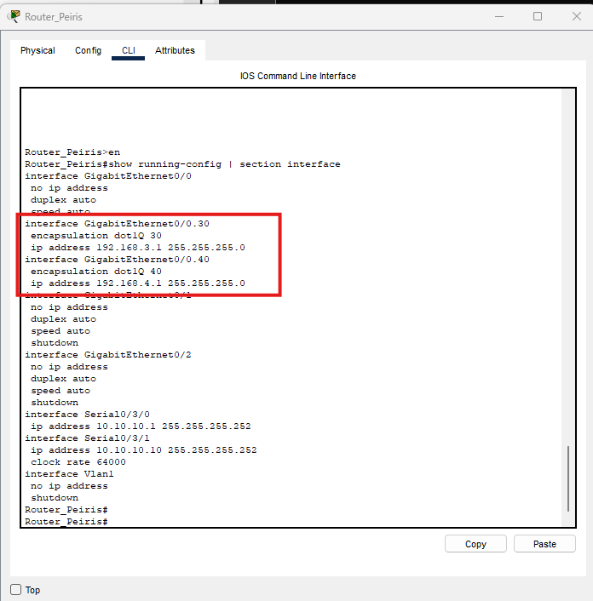

### Router_1853364

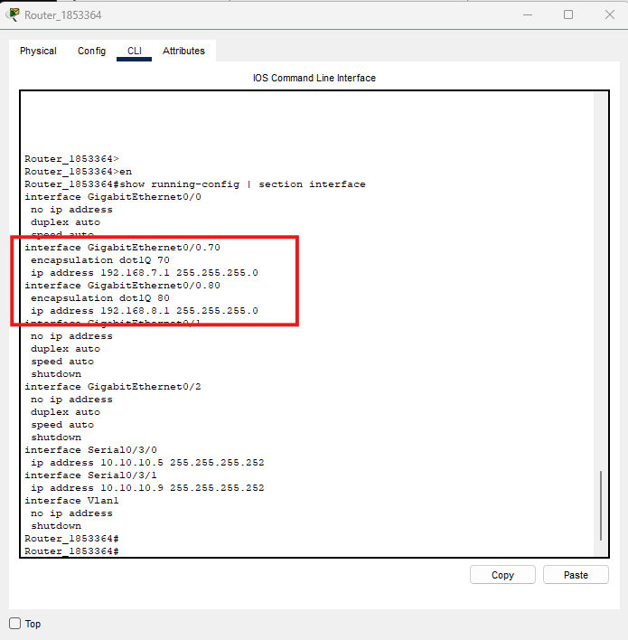

# Trunk link status (show interfaces trunk)

### SW_F1

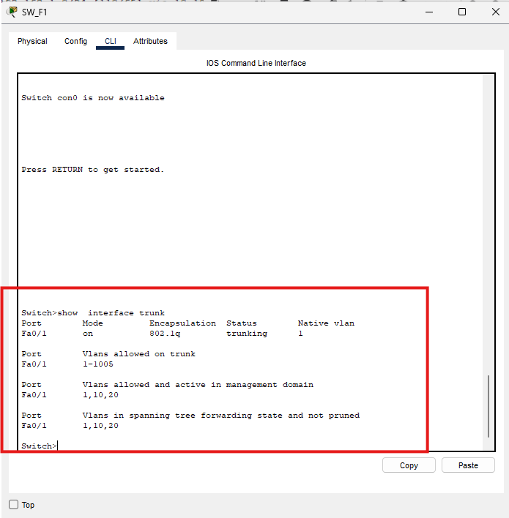

### SW_F2

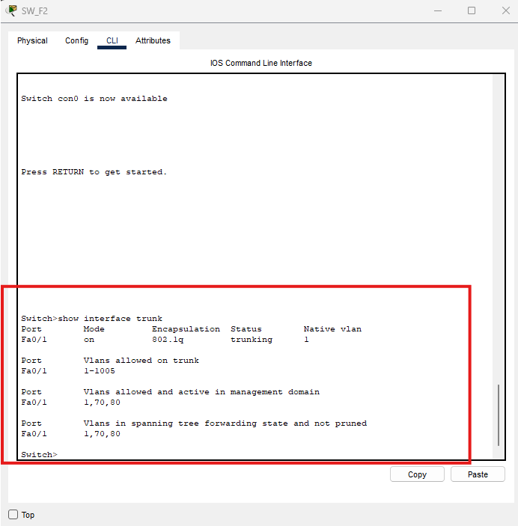

### SW_F3

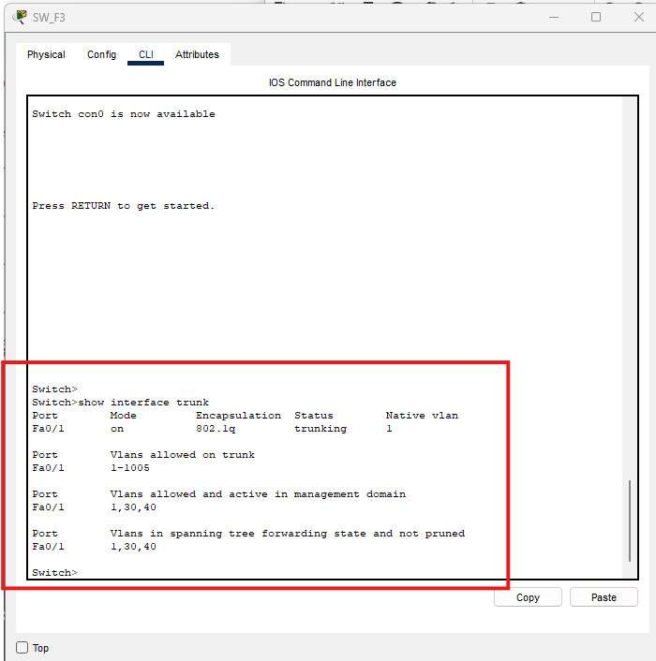

# Ping test between different VLAN PCs

# Port security violation output

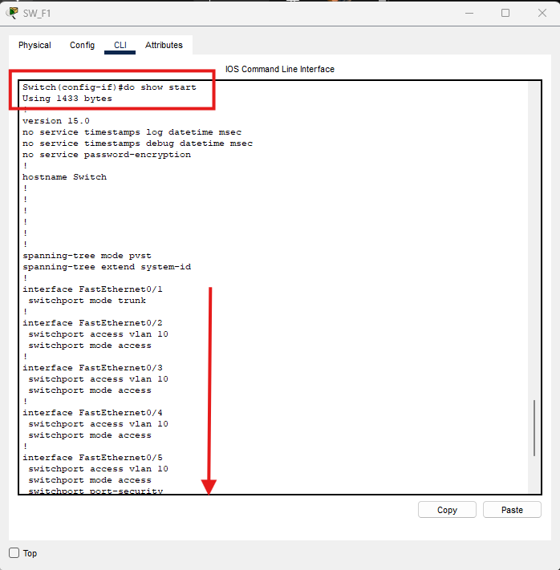

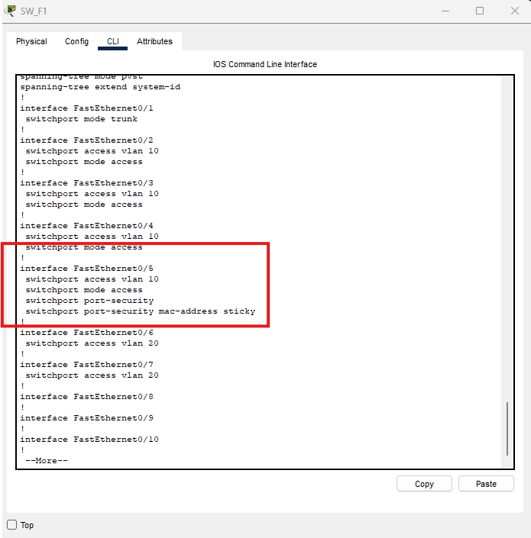



1. SSH login attempt from PC to router

Access router priris from rogue laptop using ssh

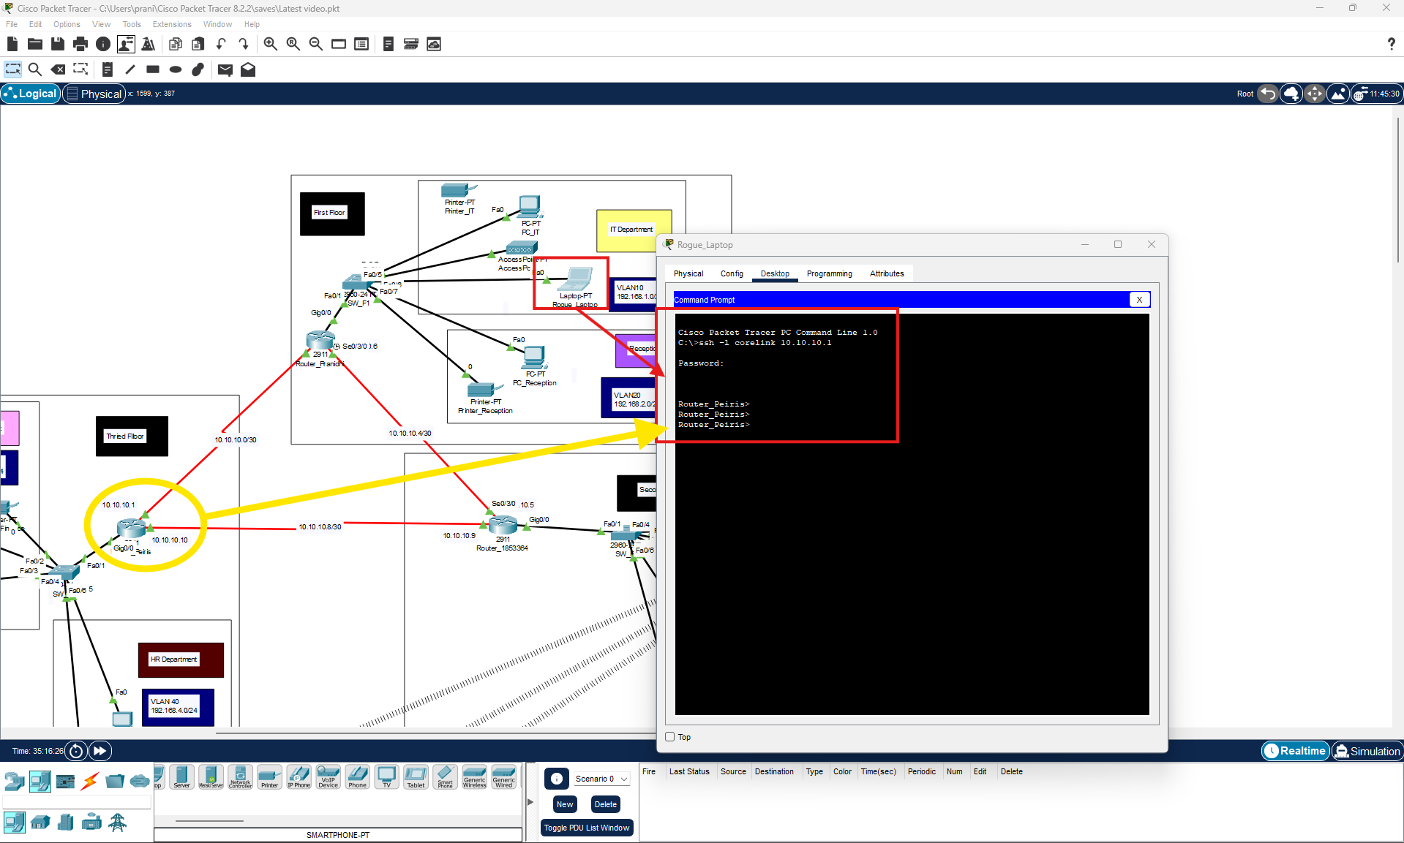

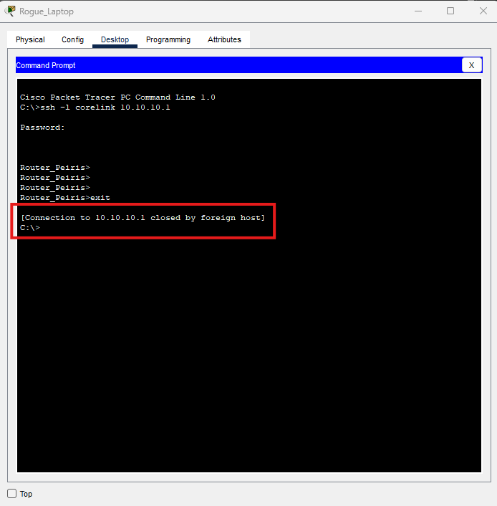

### Accessing router 1853364 using rogue laptop

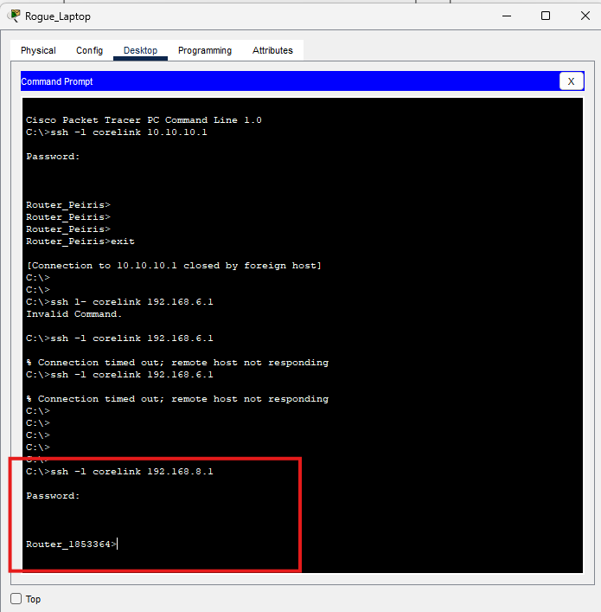

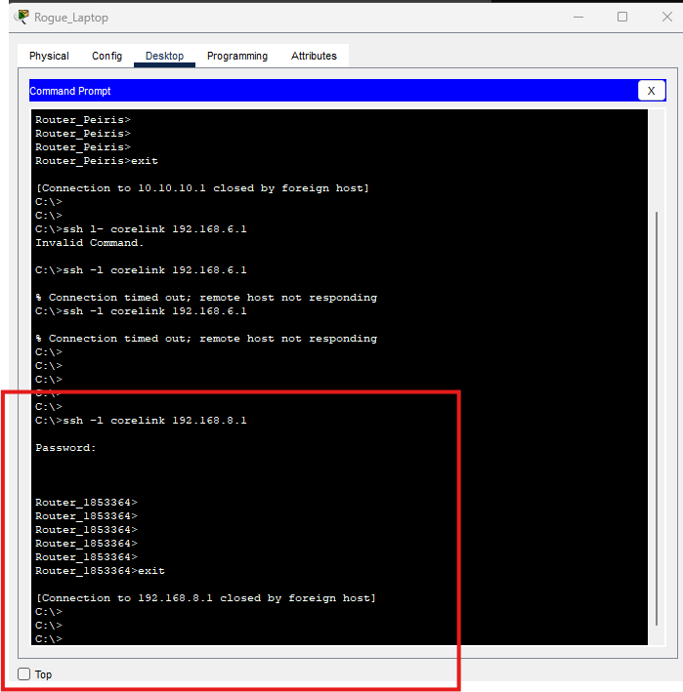

Cisco Packet Tracer Implementation

# Step 1: Create Network Topology and interface configuration (set clock rate for routers)

* Drag and place required devices (Routers, Switches, PCs, Access Points).
* Connect devices using appropriate cables:
  + **straight-through cables** for PC to switch connections and other end devices.
  + Serial DCE cables from

### Screenshot 1:

Router _Prnaidhi- interface configuratipns

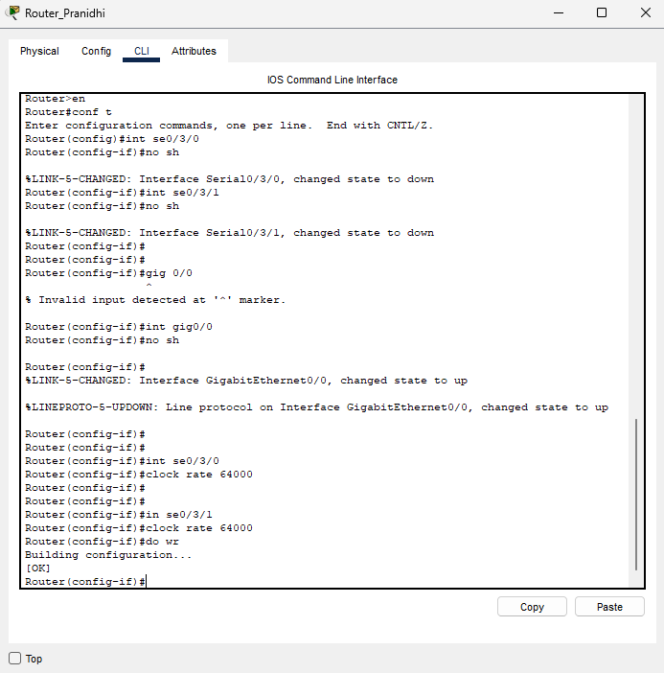

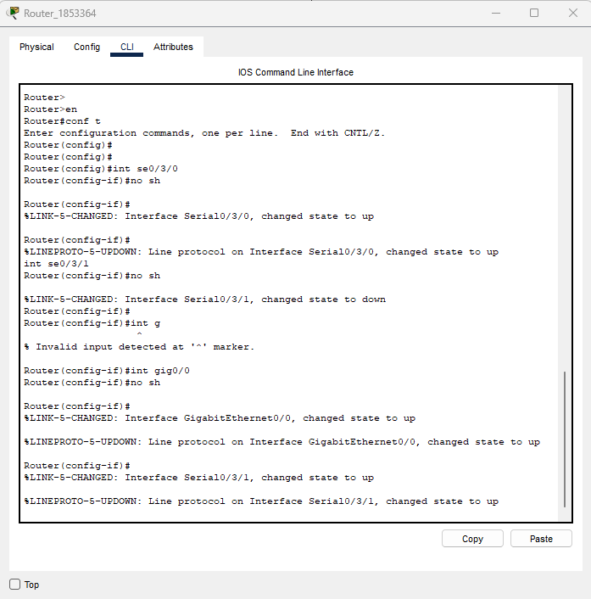

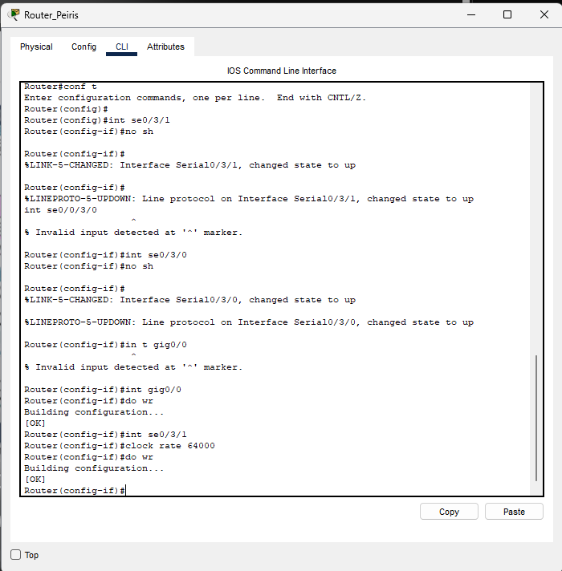

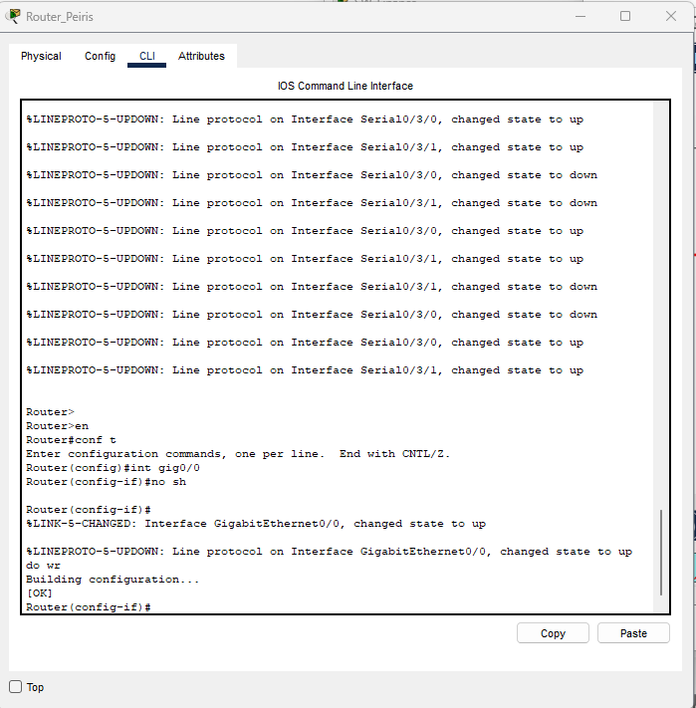

# Step 2: VLAN Creation and Port Assignment and Configure Trunk Ports

### Screenshot 3: Trunk Port Configuration

SW_IT – vlan configuration (2 departments IT (vlan10) reception (vlan 20))

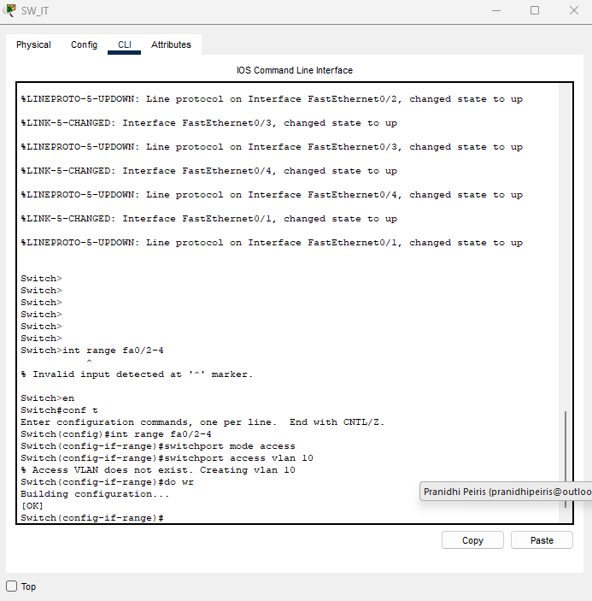

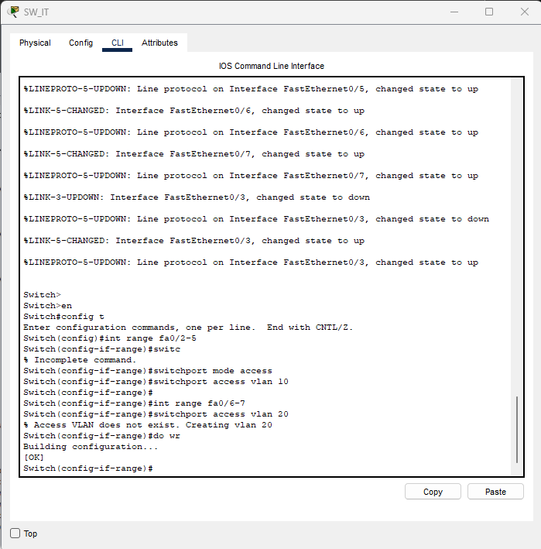

Trunk interface fa0/1

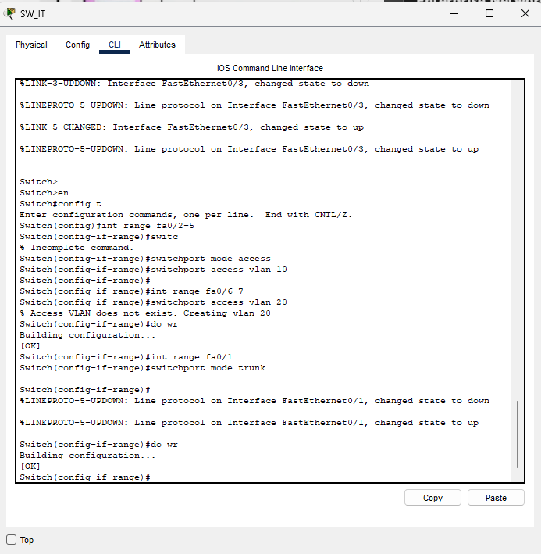

Valan configuration sw_admin

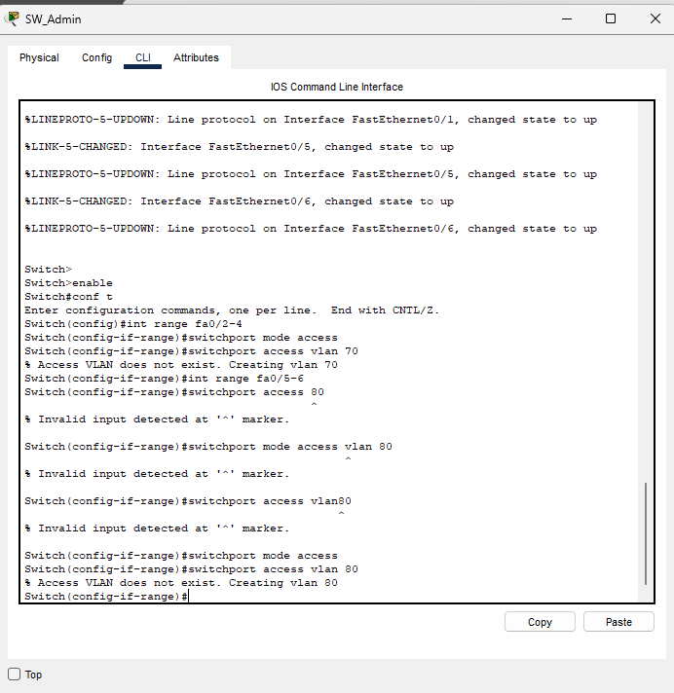

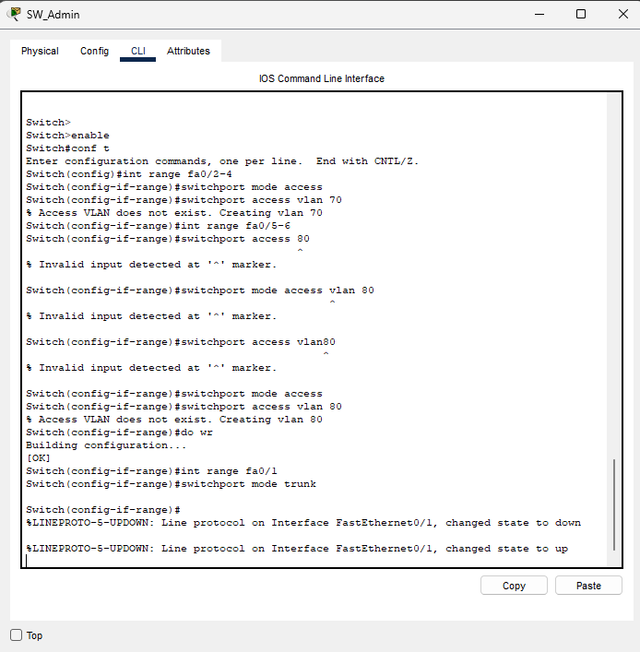

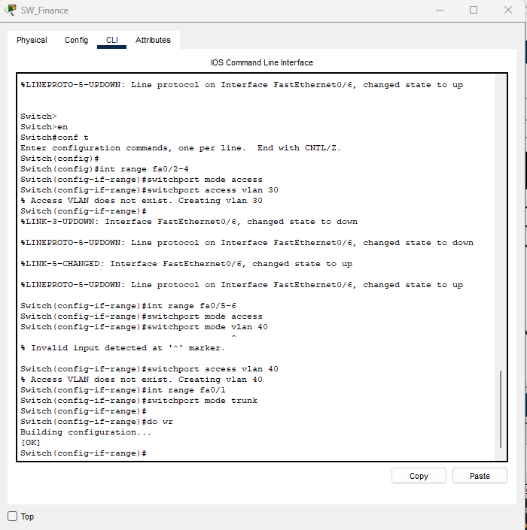

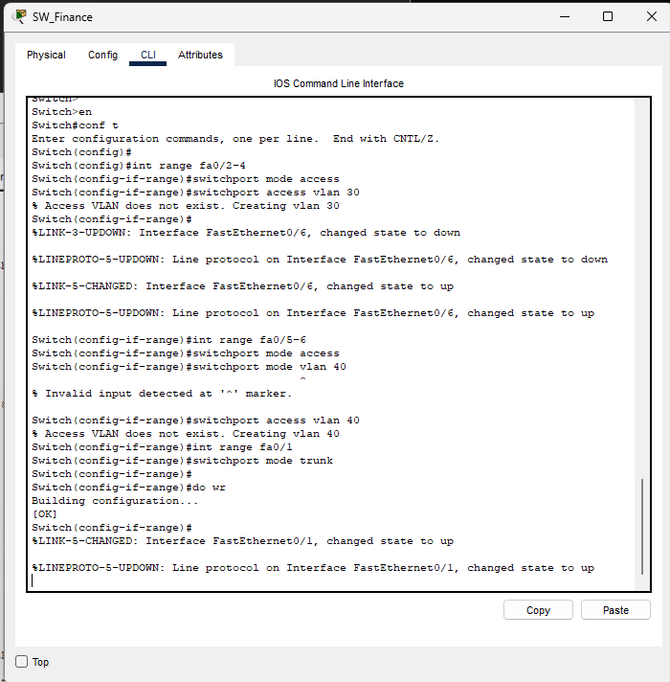

# Step 4: Router-on-a-Stick (Inter-VLAN Routing)

### Screenshot 4: Sub interface Configuration

Router Pranidhi

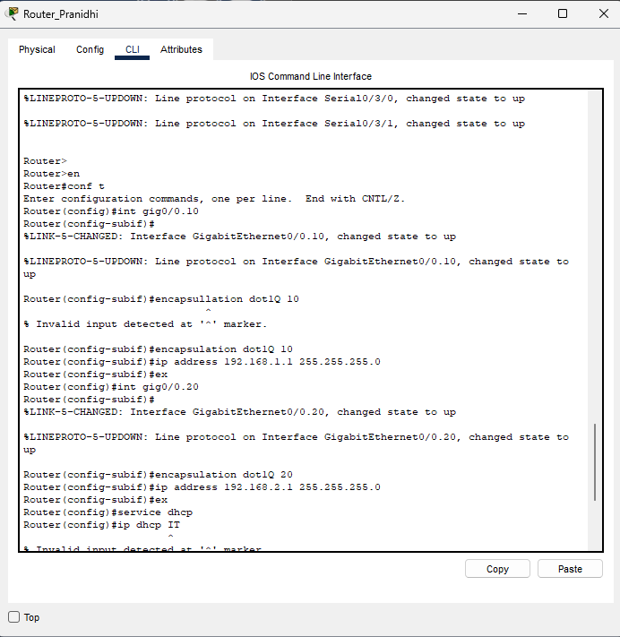

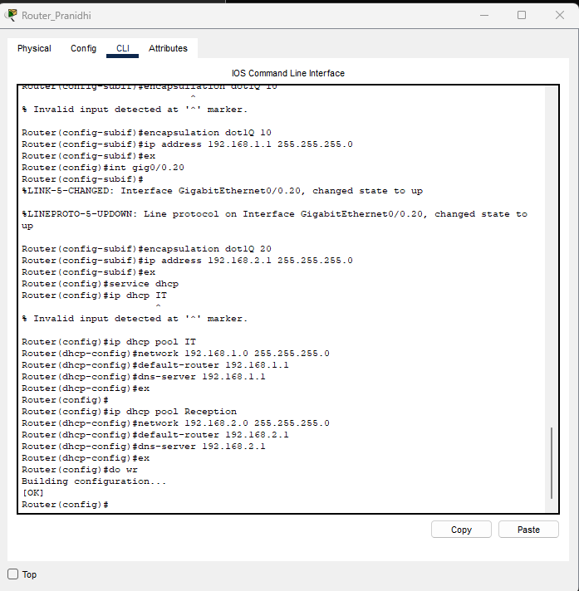

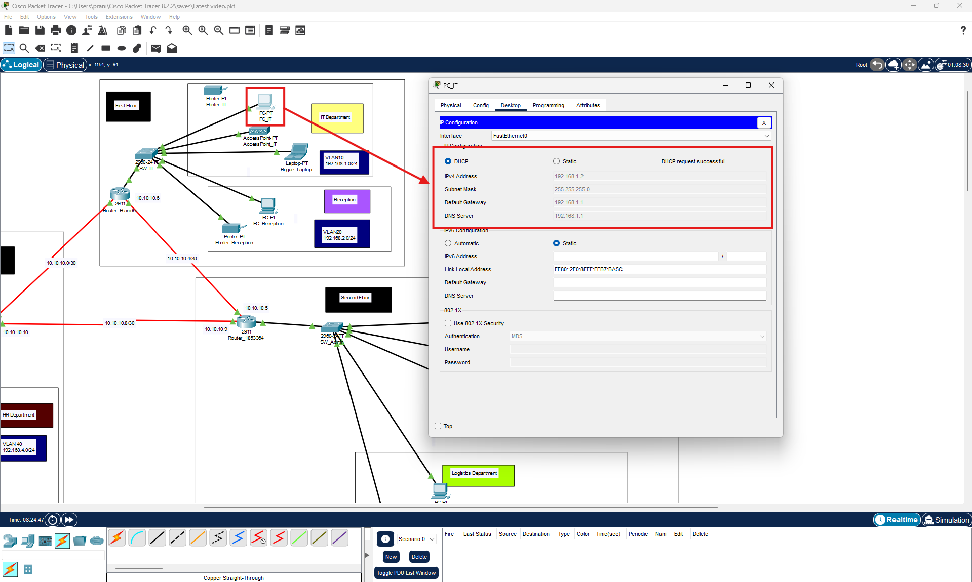

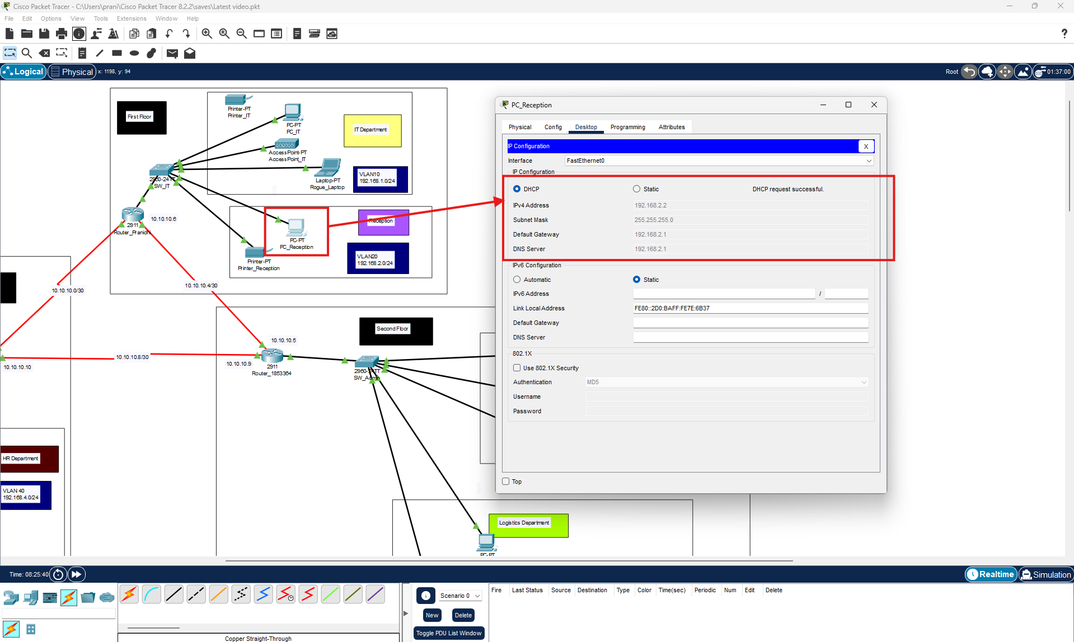

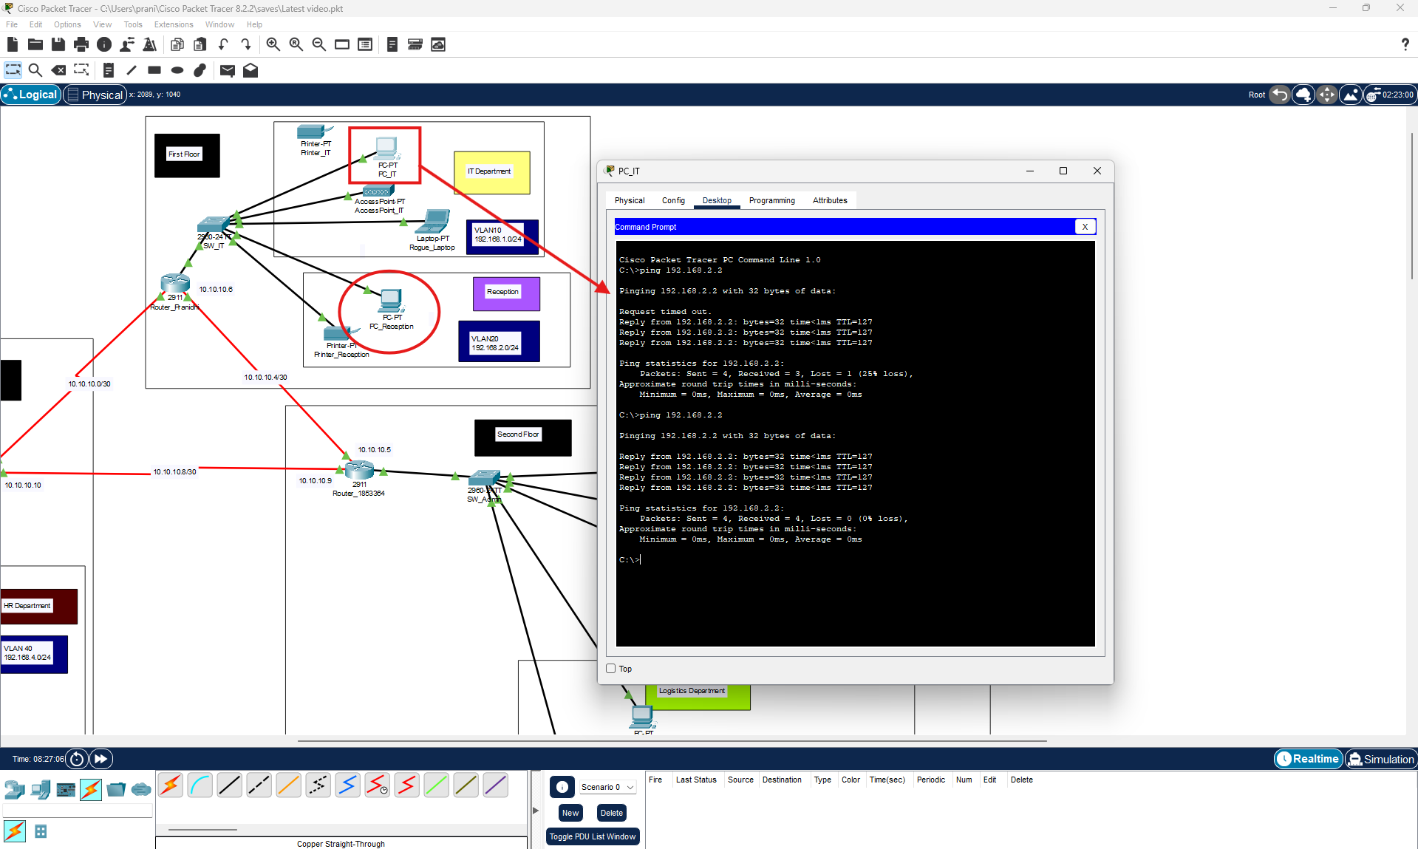

### Step 5: DHCP Configuration

### ***Screenshot 5: DHCP Pool Configuration***

Dhcp srver configuration on router 1853364

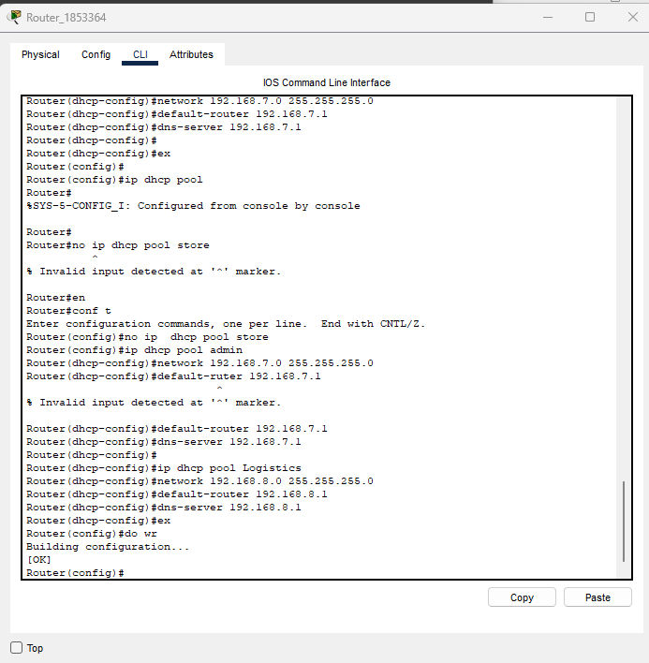

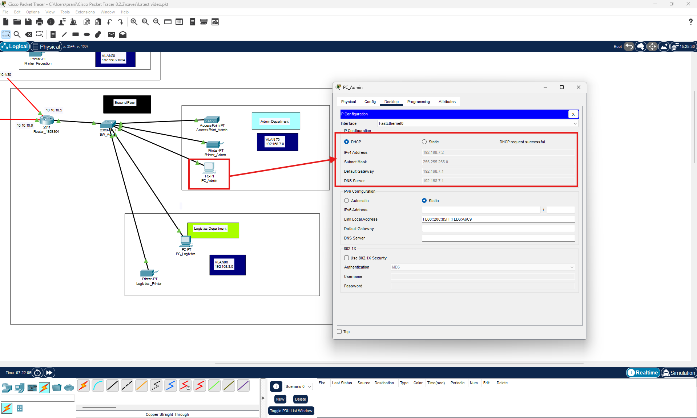

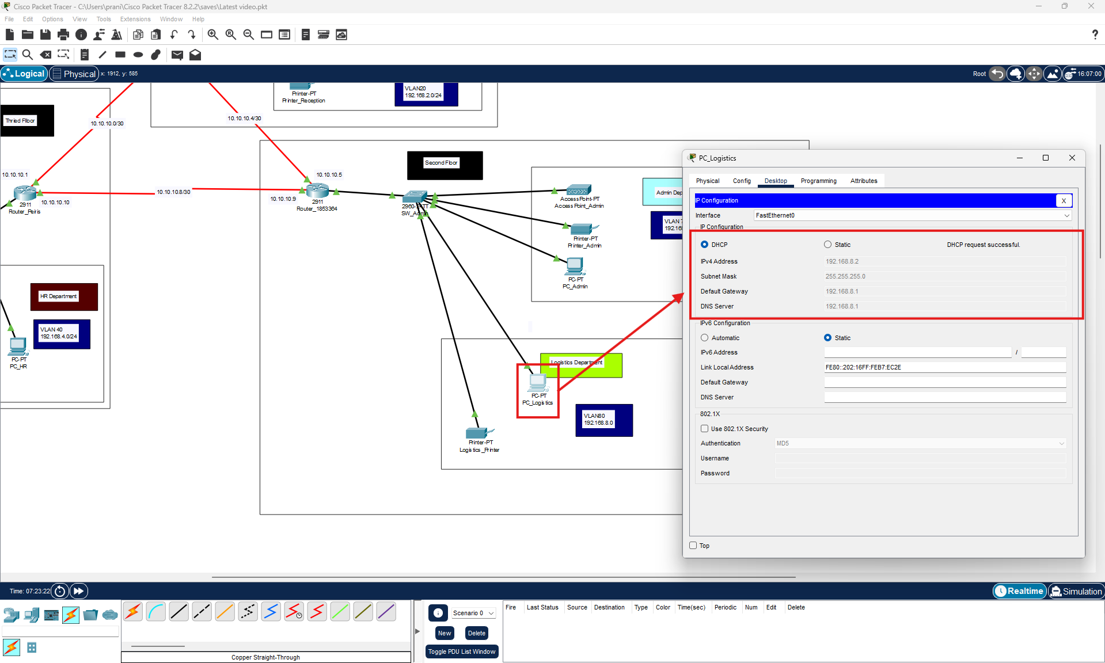

Router peiris

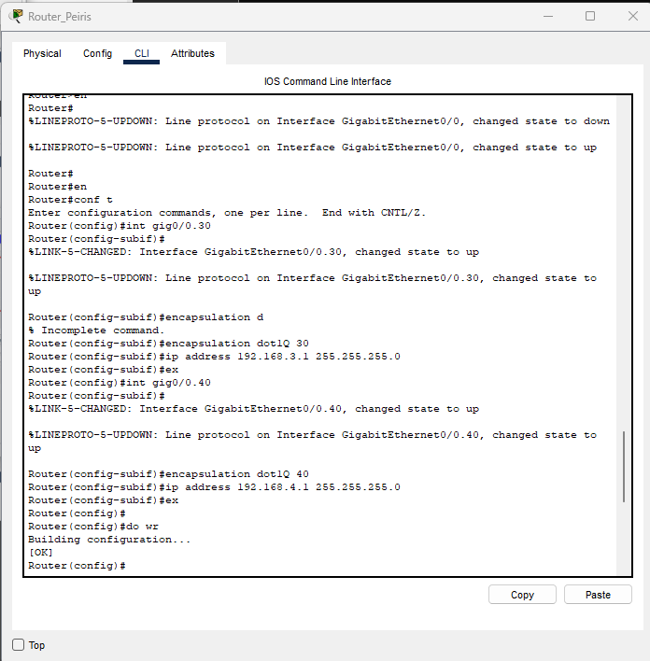

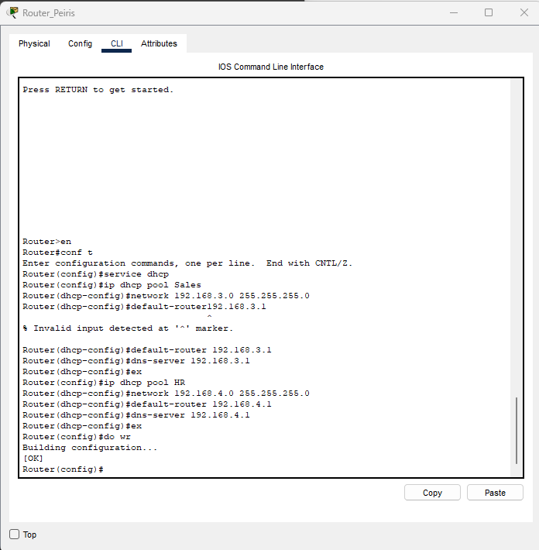

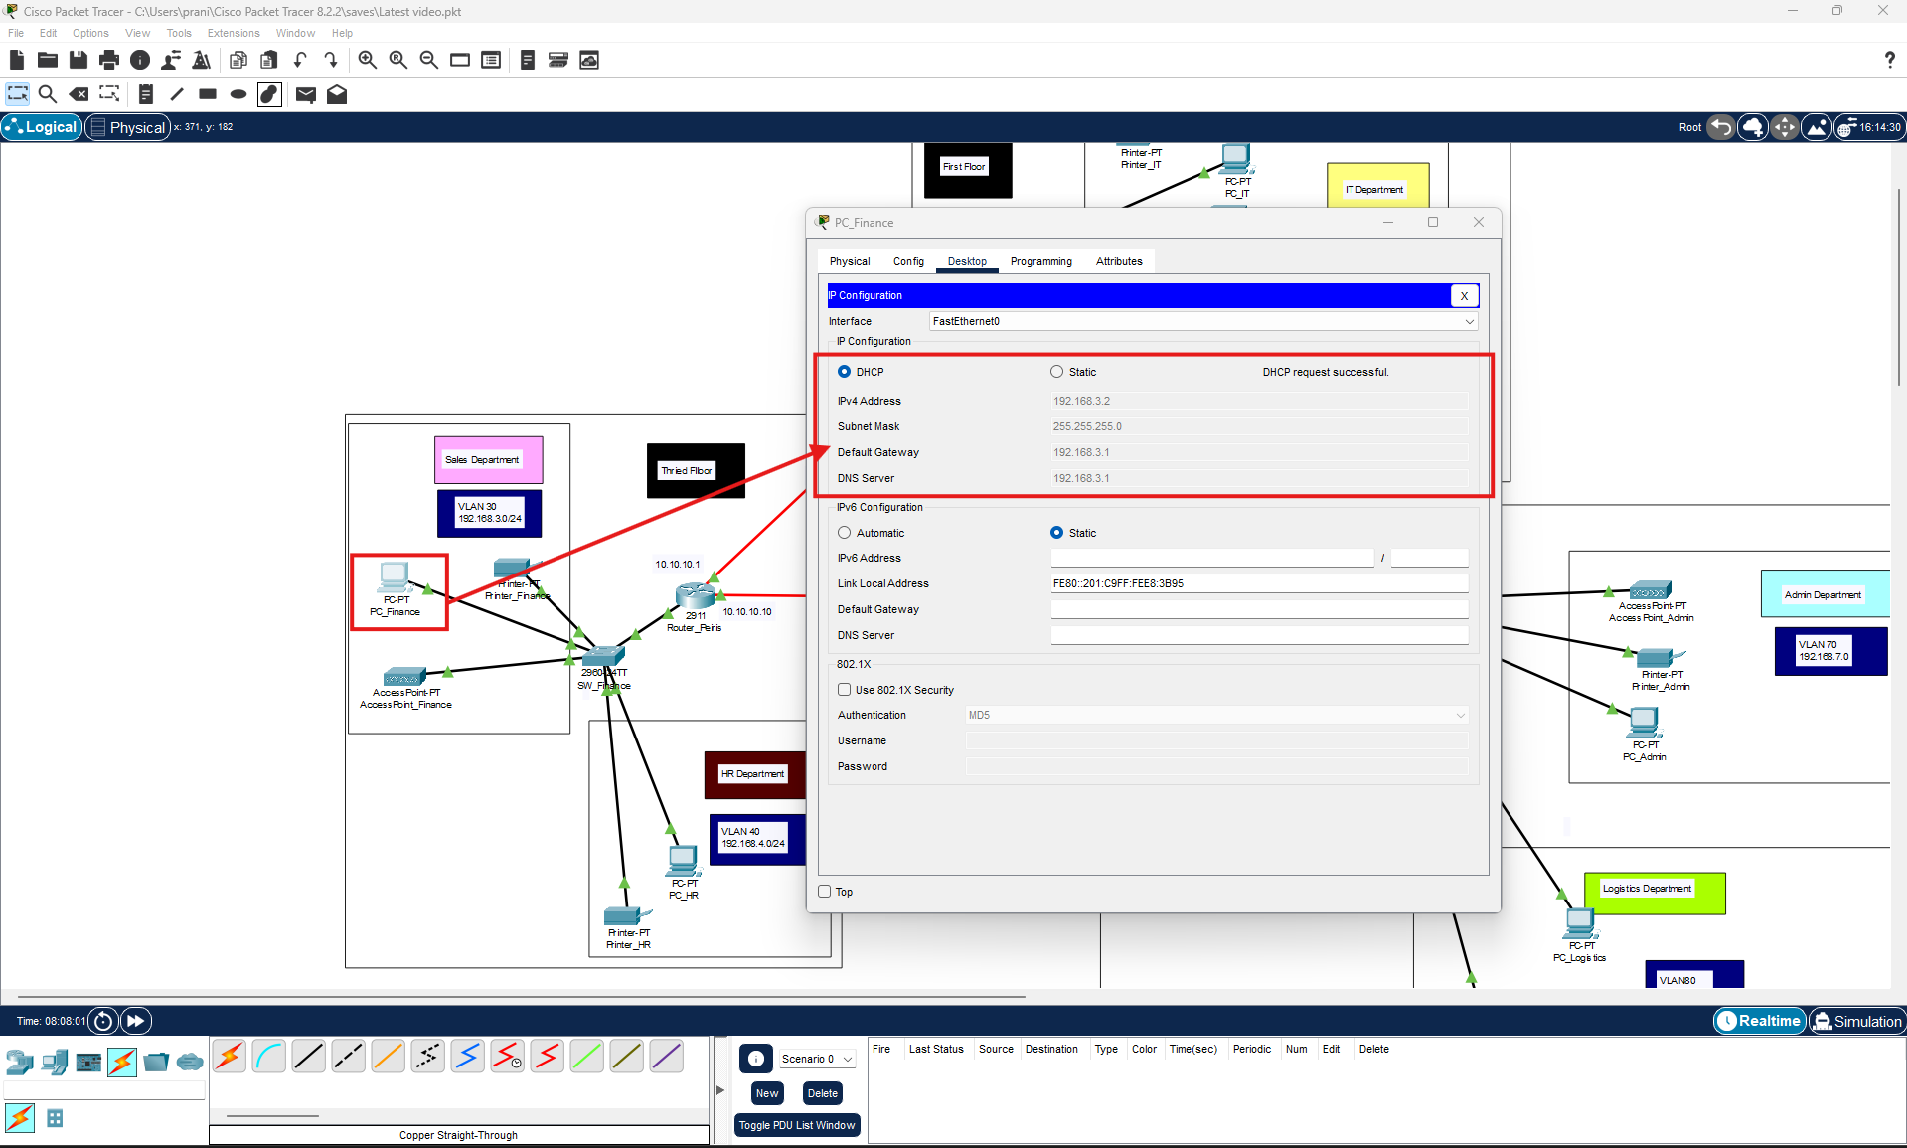

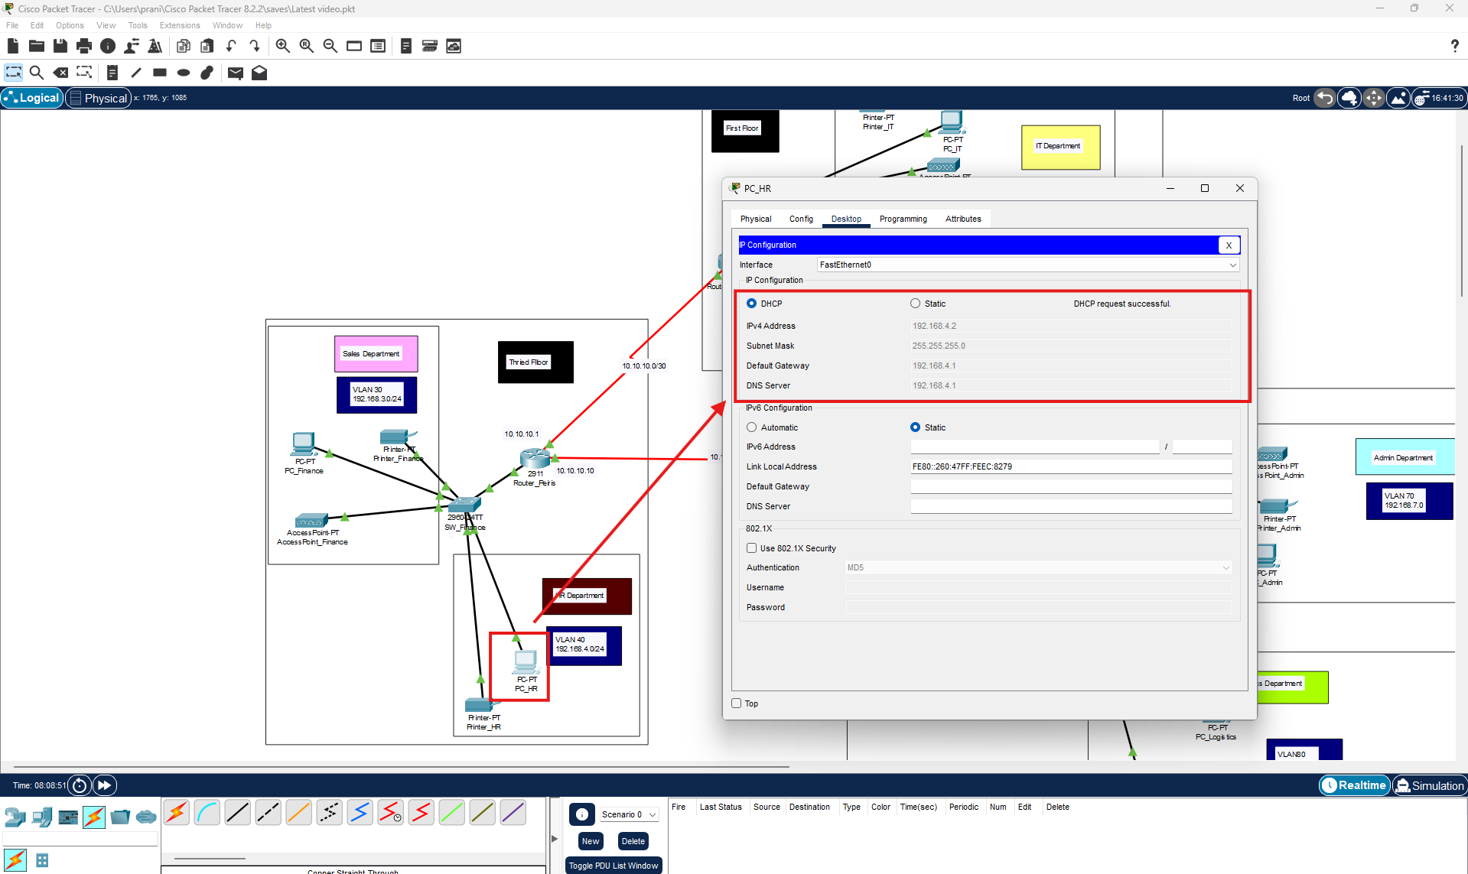

Router Pranidhi









# Step 6: OSPF Routing Configuration

### Ospf configuration on router peiris

### Screenshot 6: OSPF Routing Setup

* 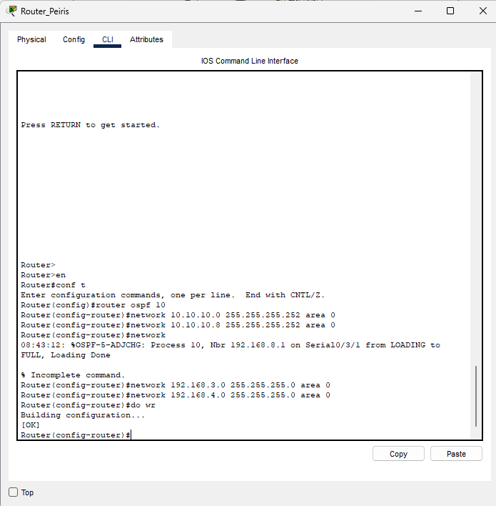

Ospf configuration router pranidhi

* 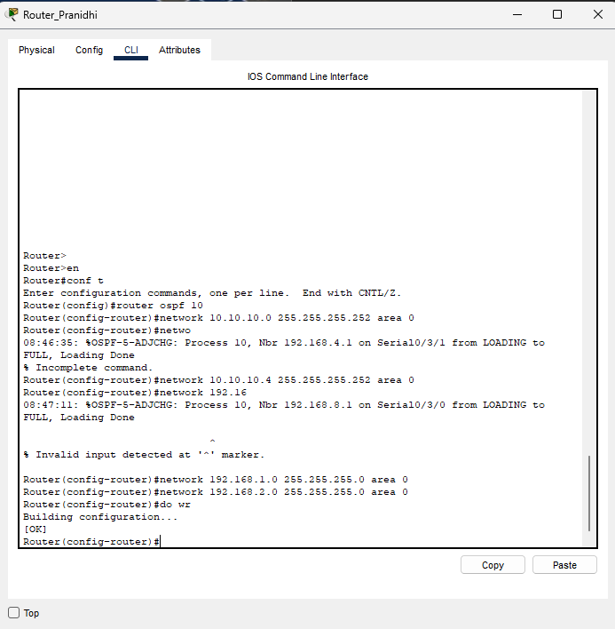

# **Step 7: Wireless Access Point Configuration**

* Configure each access point:
  + Set SSID
  + Enable WPA2 security
  + Assign static IP in VLAN subnet

### Screenshot 7: Wireless AP Configuration

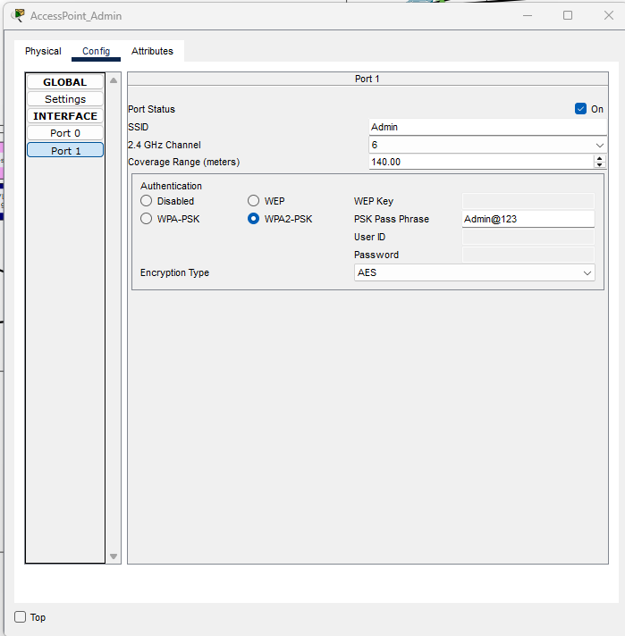

Connect devices to access points

Laptop

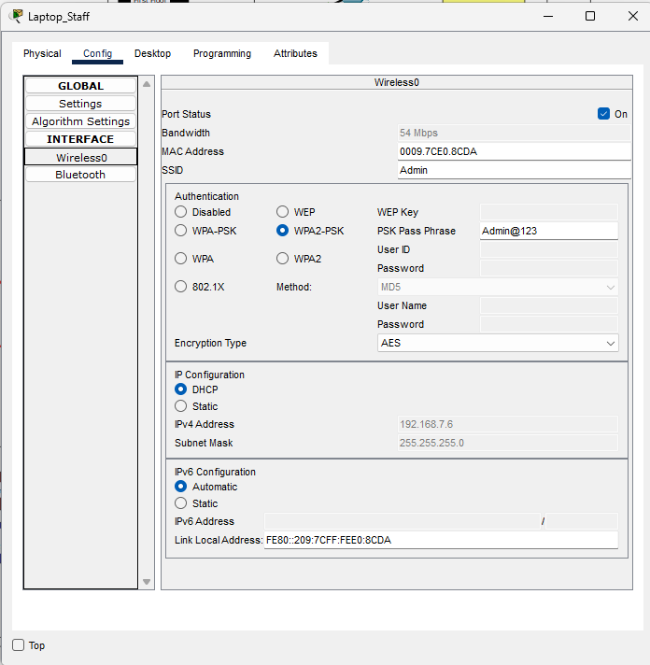

Move to desktop tab->PC Wireless option

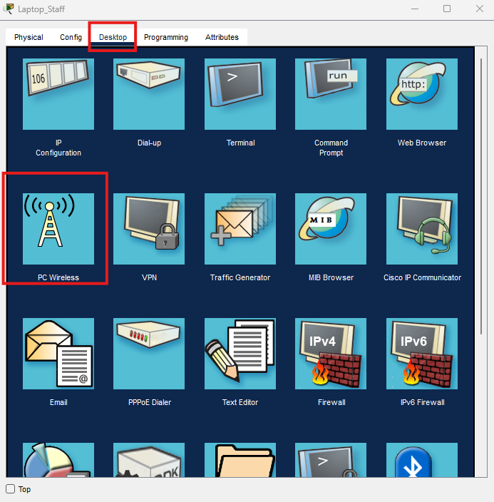

Move to the connect tab and then click on refresh button

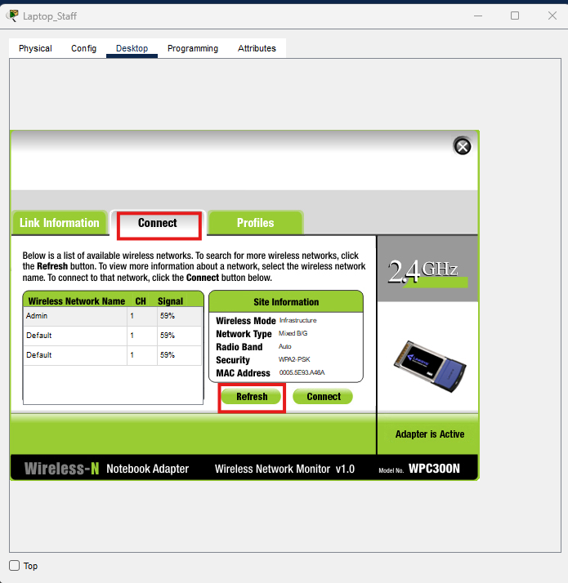

Select admin and click on connect button

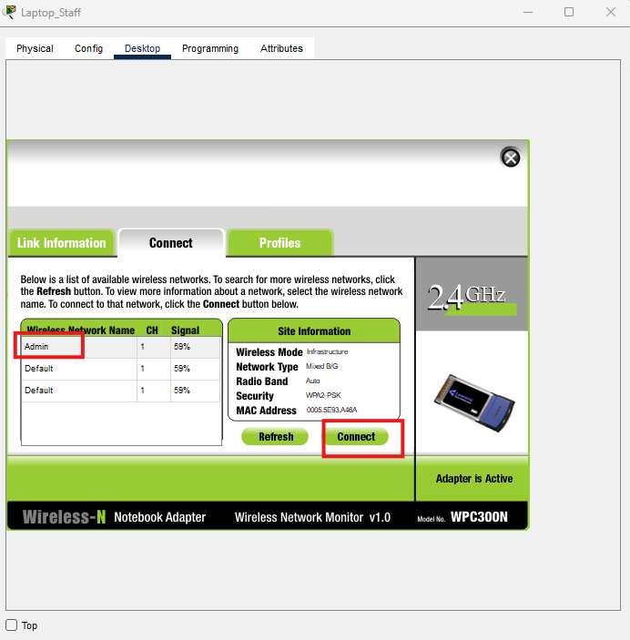

Enter the key and click on connect button

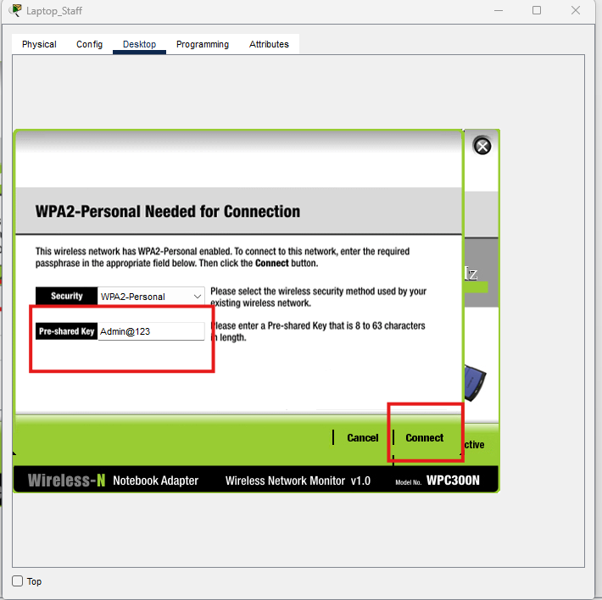

Tablet

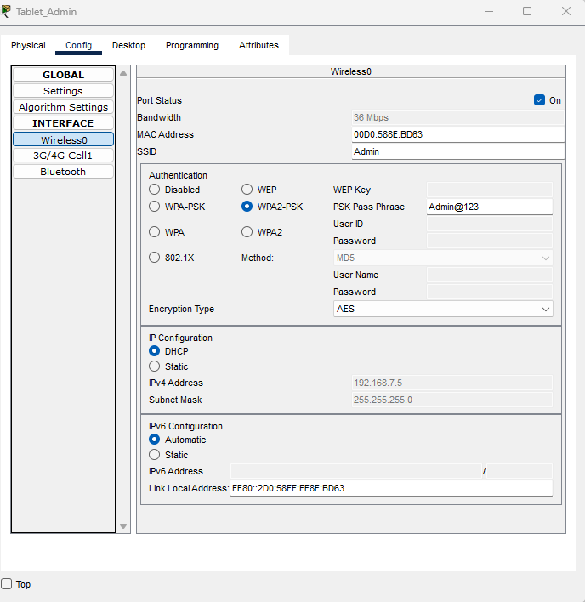

Mobile phone

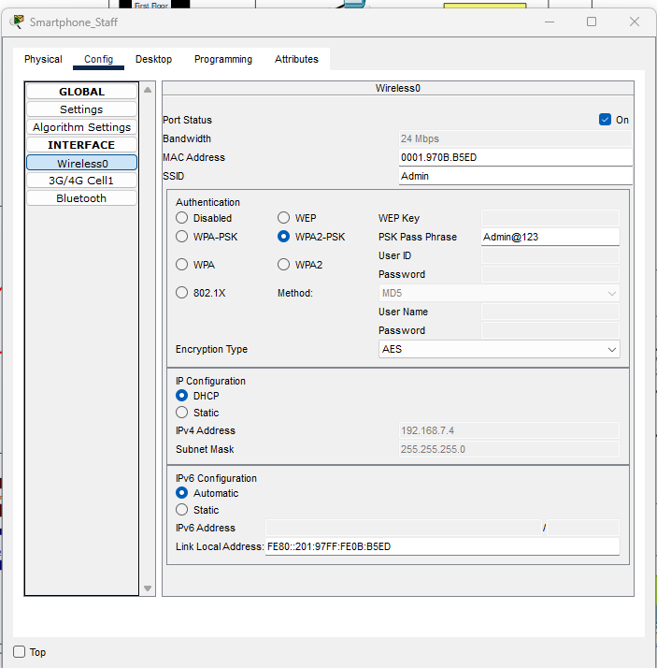

# Step 8: SSH Configuration on Router

* Configure secure remote login:
* Configure ssh on router Pranidhi

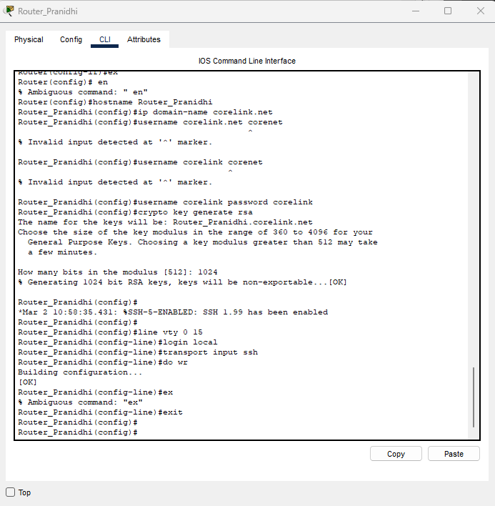

Router peiris

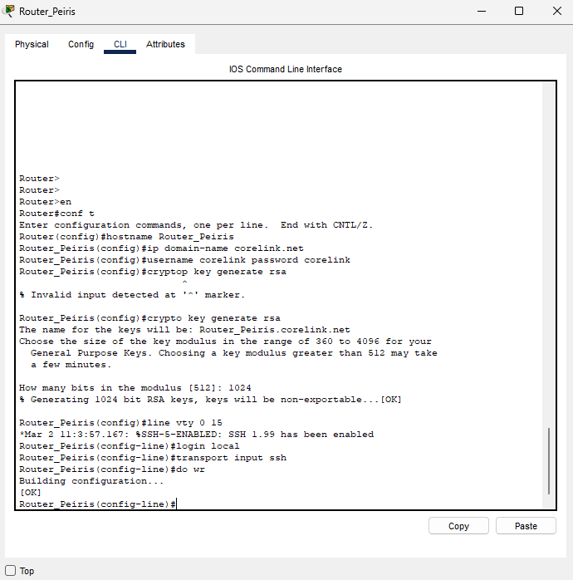

Router 1853364

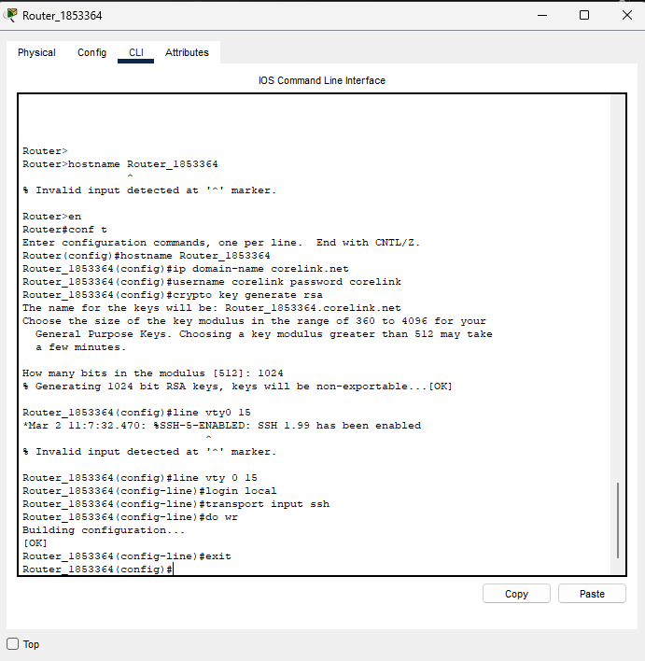

### Screenshot 8: SSH Remote Access Setup

Access router peiris from rogue laptop using ssh





**Accessing router 1853364 using rogue laptop**





# Step 9: Port Security Implementation

### Screenshot 9: Port Security Setup

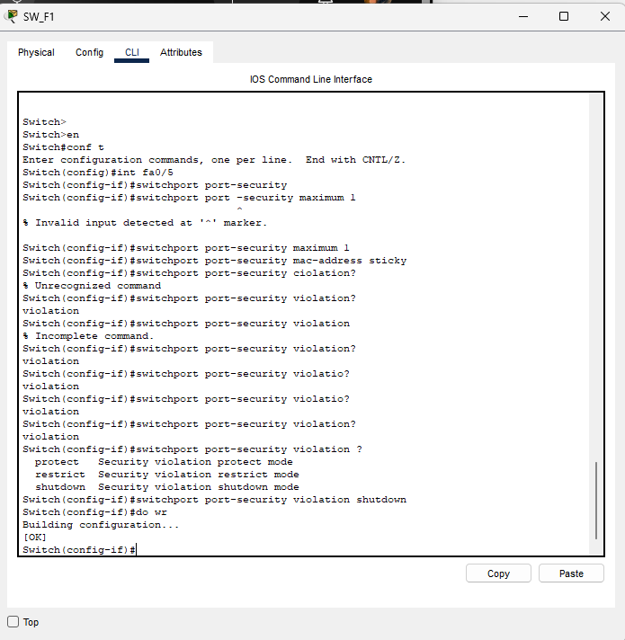

Verify port security. configure port security to it department switch SW_F1 to allow only rogue laptop to access port fa0/5 using sticky method to obtain mac address with violation mode of shutdown





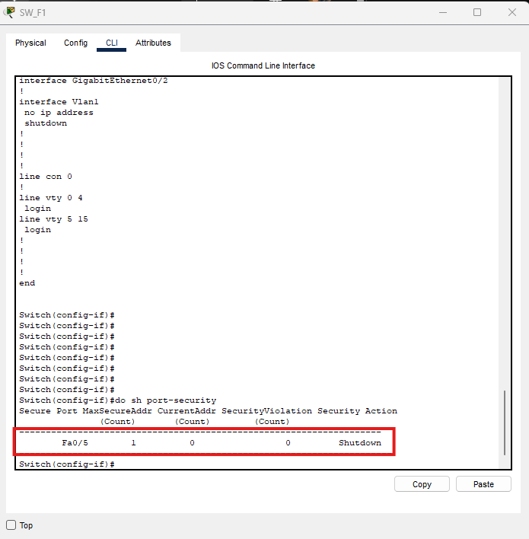

# Step 10: Testing and Validation

* Use **ping** to test inter-VLAN and OSPF connectivity.
* Simulate MAC address violations.
* Perform SSH login test from a PC.

## Screenshot 10: Ping Tests and Final Validation

Testing PCIT-> Rogue Laptop

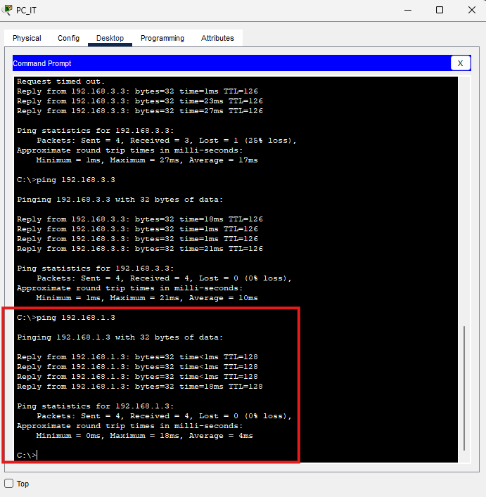

PC_IT- PC_Reception

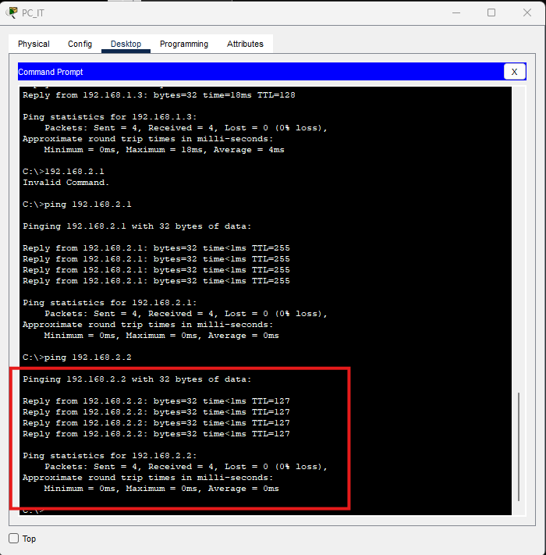

Pc-it- printer_admin

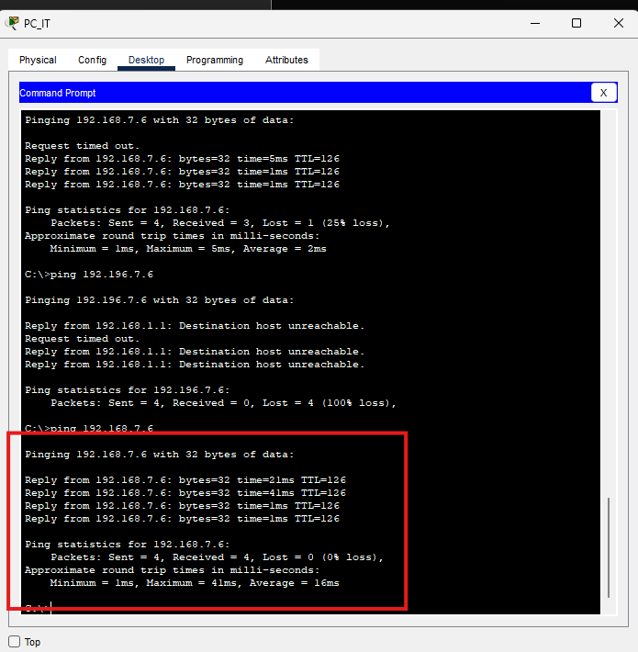

Pc-it – pc-admin

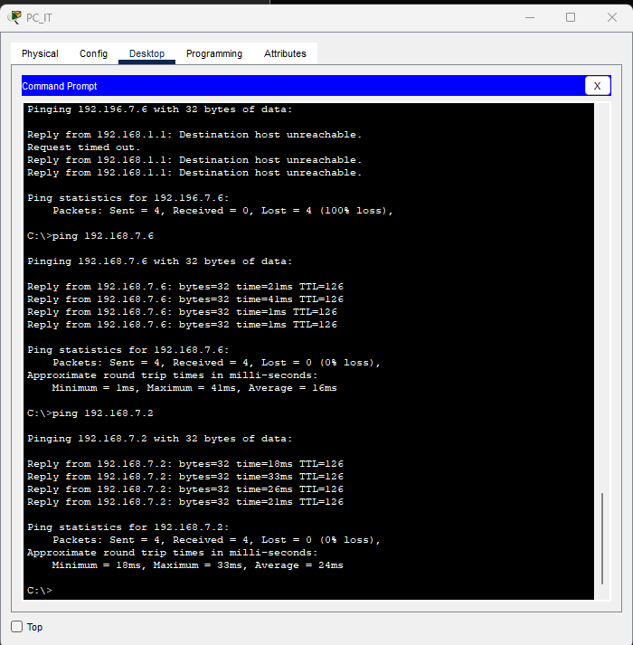

Pc_it – pc-logistics

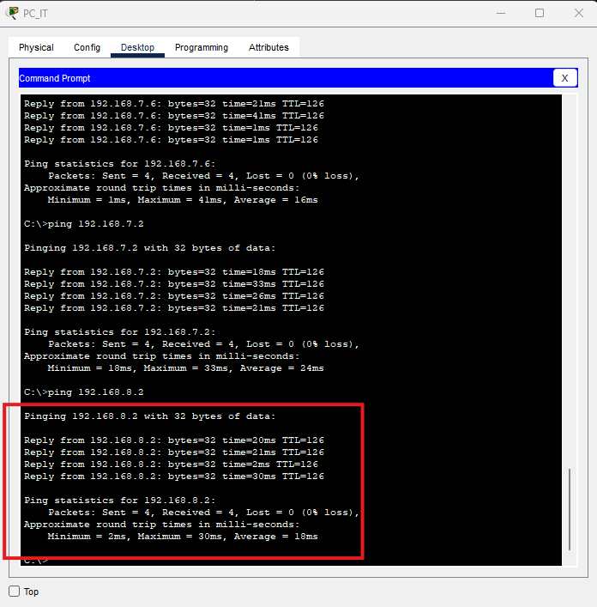

Pcit-logistic-printer

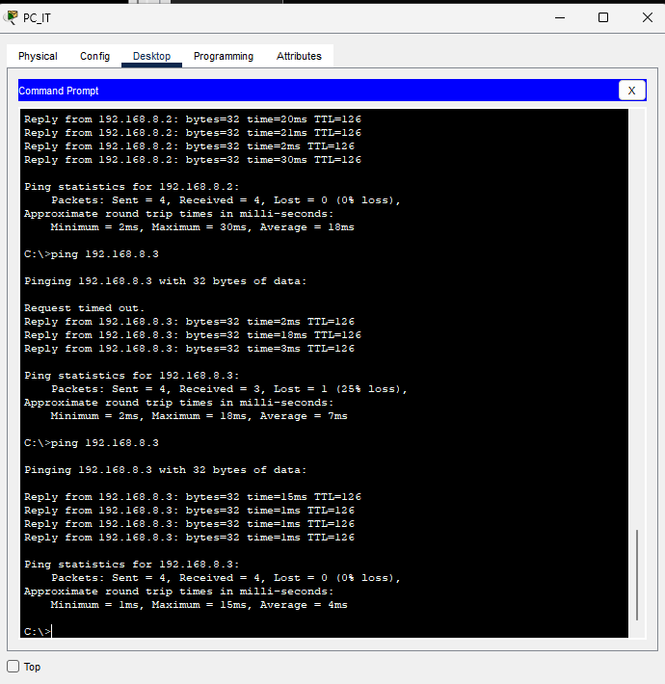

Pc_It- smartphome staff

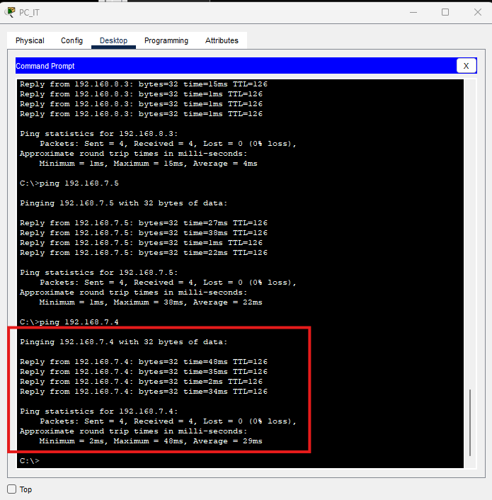

Pc_it to laptop staff

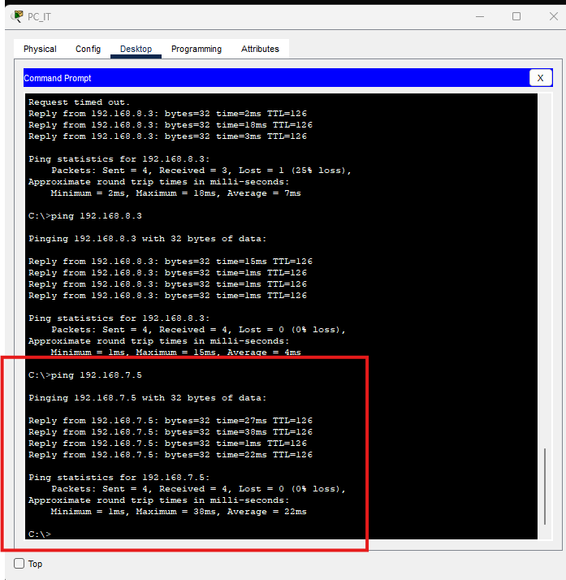

Pc_It to table_admin

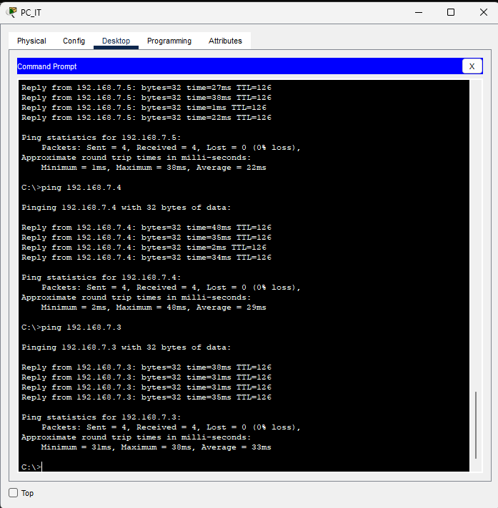

PC_IT – PC_HR

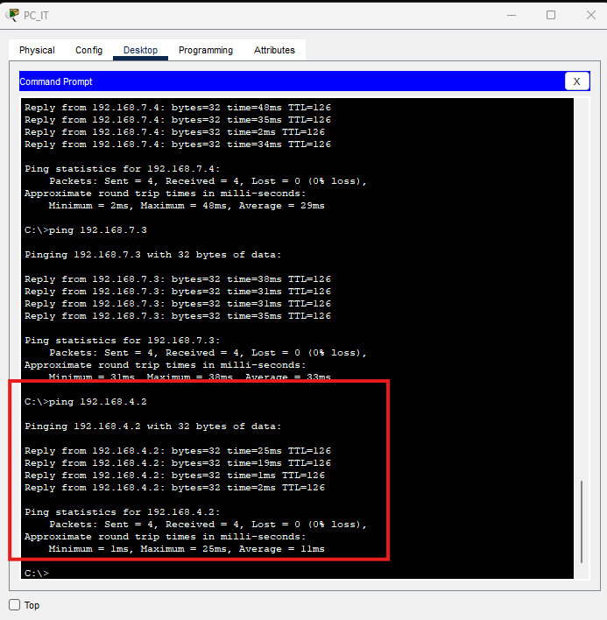

PC_IT -> Printer_HR

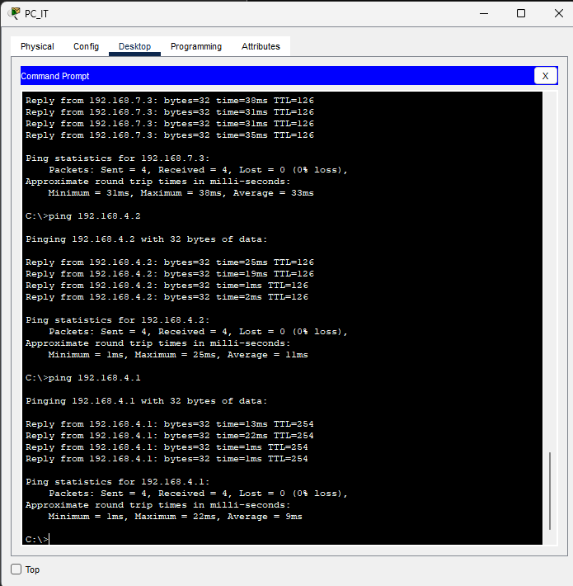

PC_Sales

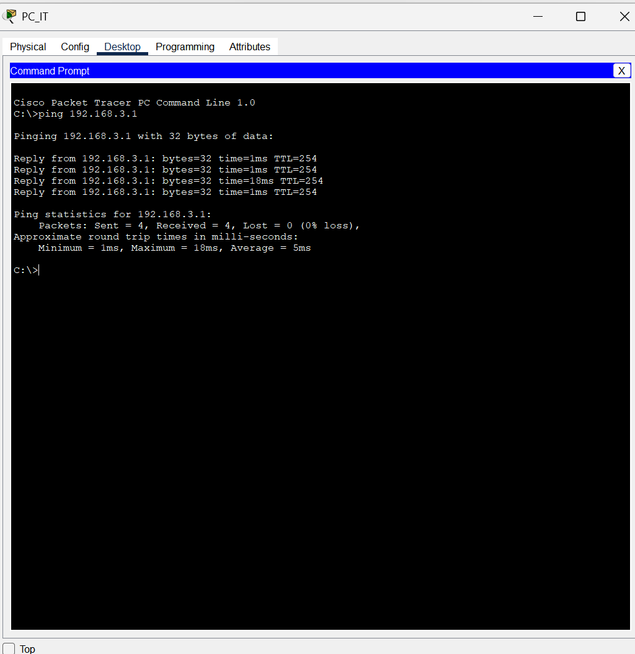

Printet_Sales

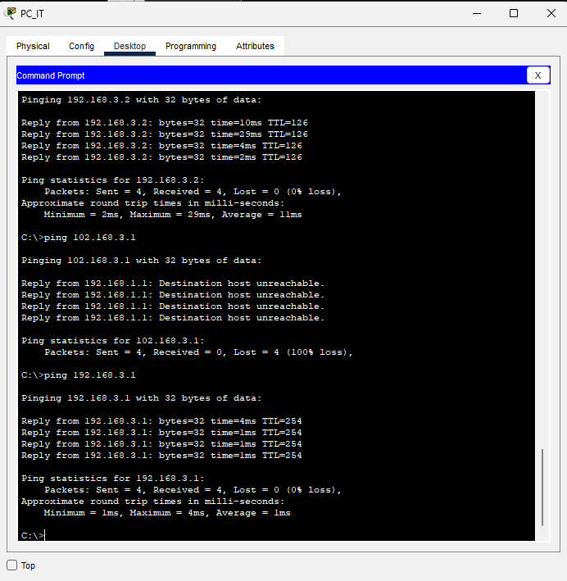

Router Pranidhi

Interfaces0/3/1 10.10.10.2

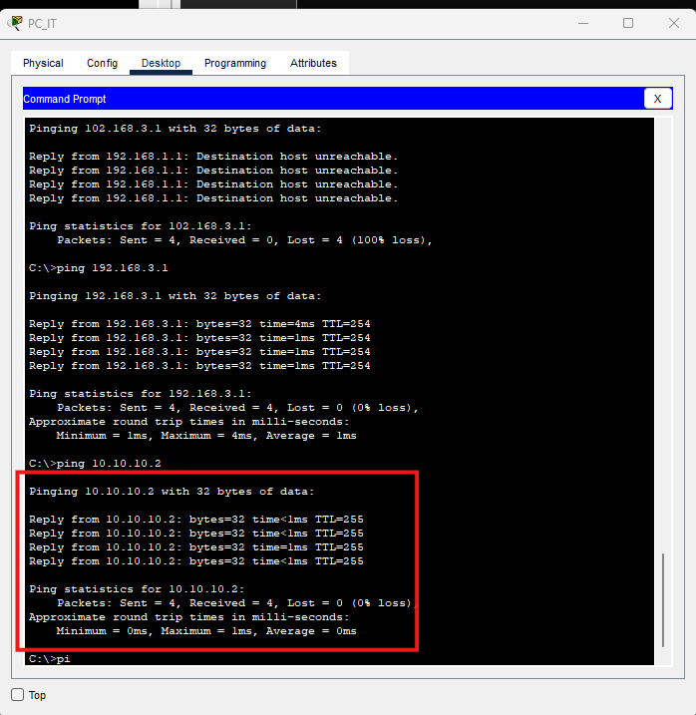

Interfaces0/3/0 -10.10.10.6

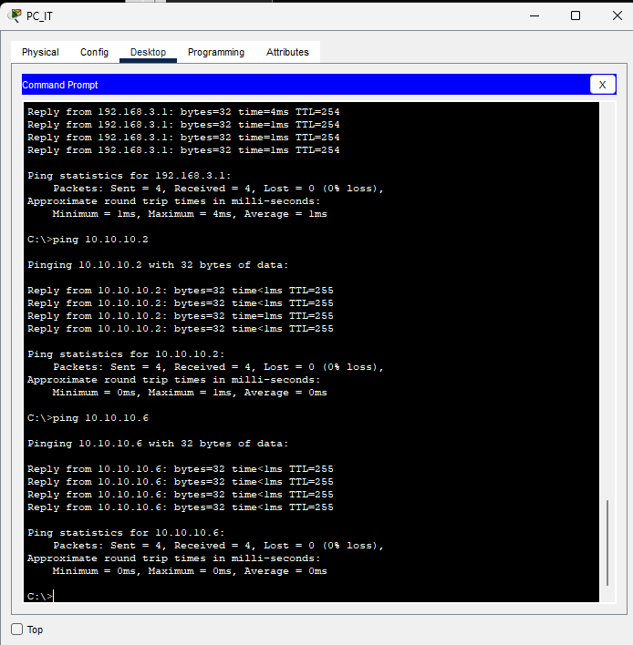

Router peiris

Interfaces0/3/0 -10.10.10.1

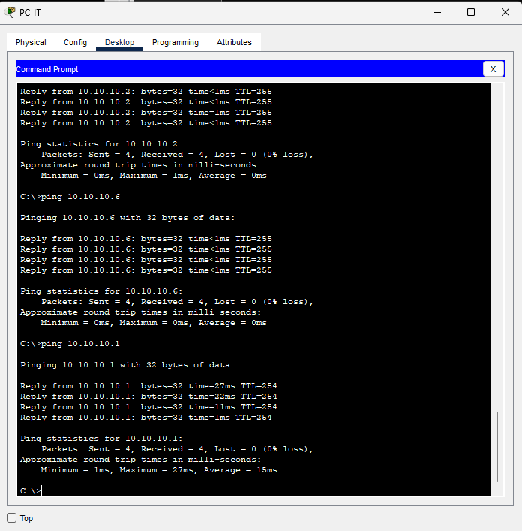

Interfaces0/3/1 10.10.10.10

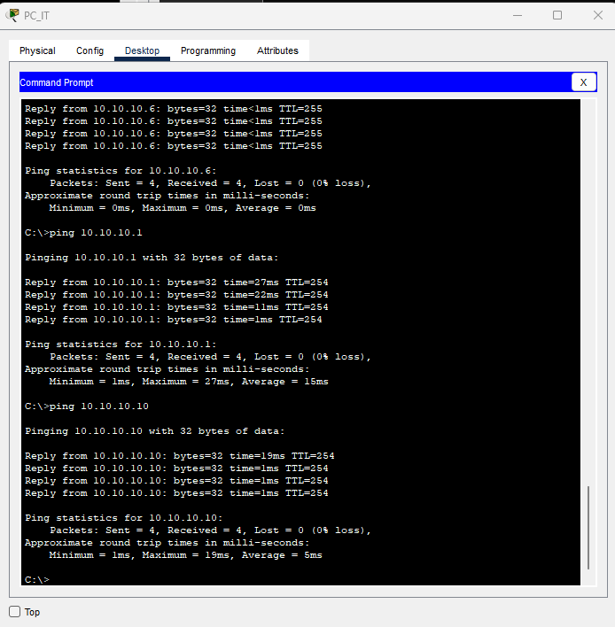

Router 1853364

Interface s0/3/0 10.10.10.5

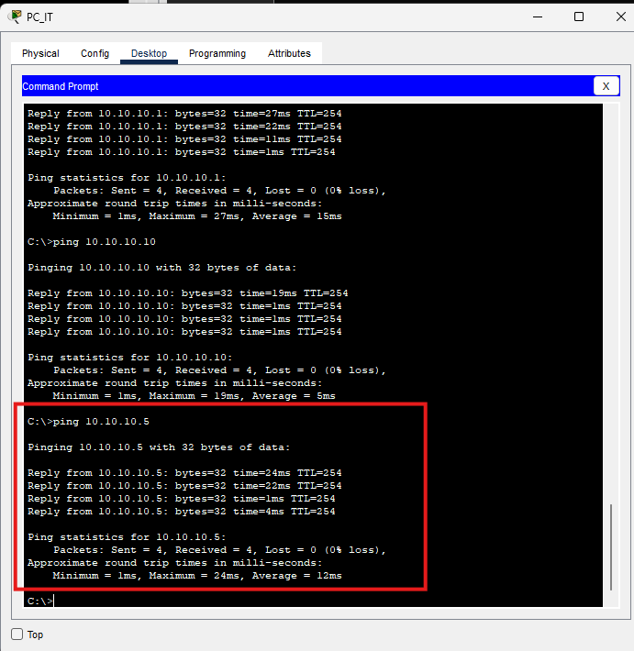

Interface s0/3/1 10.10.10.9

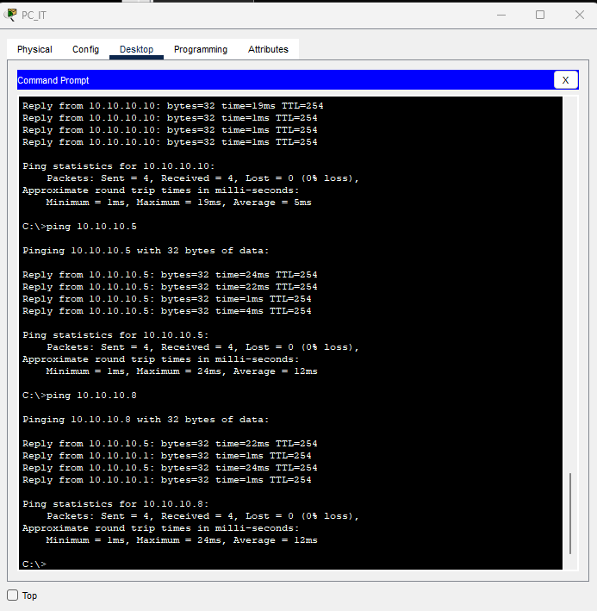

* **Logical topology** (showing VLANs, routers, switches)

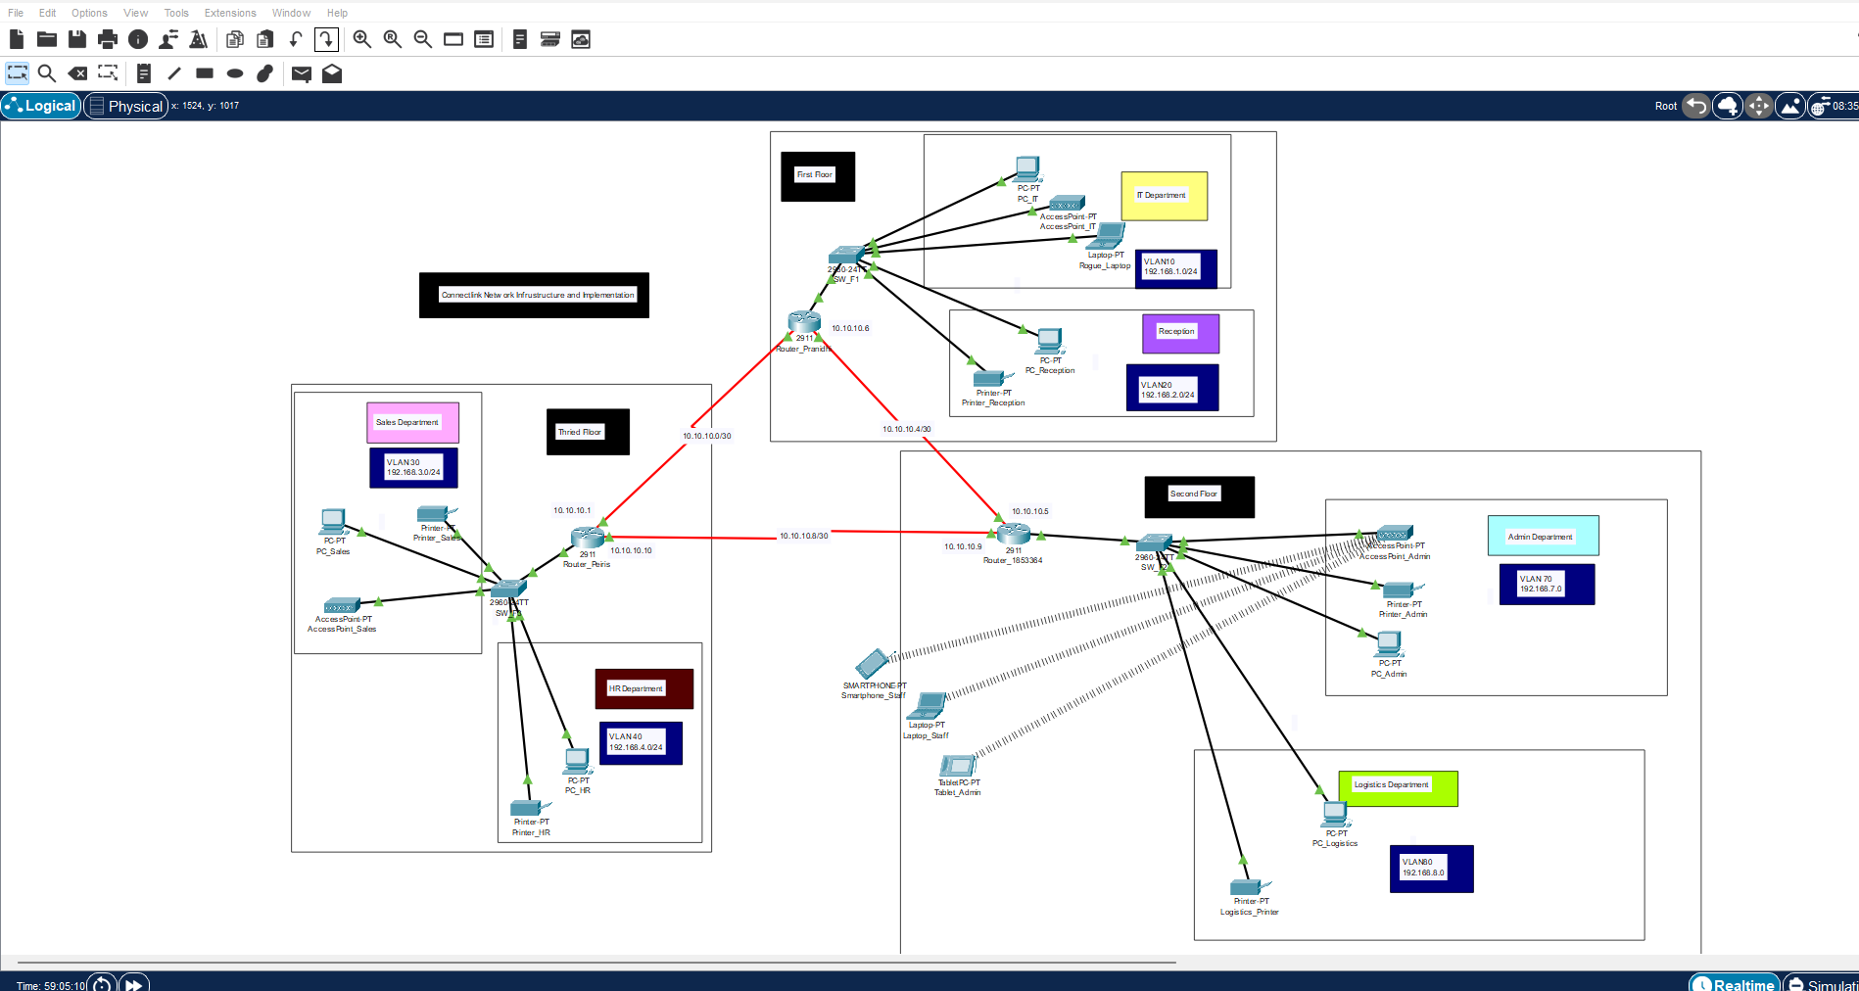

**10.Knowledge Integration Summary**

This network design reflects integration of core concepts including layered models (TCP/IP), dynamic routing (OSPF), secure access (SSH, port security), and VLAN-based segmentation. By combining wired and wireless infrastructure within a scalable, secure framework, the design supports current operations and future growth for Connect Link.

11. References

1. Ahmad, I., Ashraf, Dr.Javed. and Nasir, Dr.Anisur.R. (2020). Design and Implementation of Network Security using Inter-VLAN-Routing and DHCP. Asian Journal of Applied Science and Technology, 04(03), pp.37–44. doi:https://doi.org/10.38177/ajast.2020.4306.
2. Balarabe, A.T., Hassan, Z.L. and Rufa’i, A. (2019). Implementation of RIPv1 and OSPF Routing Protocol, DHCP, DNS, and HTTP Configurations in CISCO Packet Tracer. IJIREEICE, 7(4), pp.1–8. doi:https://doi.org/10.17148/ijireeice.2019.7401.
3. Chukwudebe, G. (2014). Network Protocols and its Implication on Connectivity and Configuration. [online] Academia.edu. Available at: https://www.academia.edu/117684720/Network_Protocols_and_its_Implication_on_Connectivity_and_Configuration?nav_from=e8e1d63f-51e0-4e00-a0db-90ca97c3ff03 [Accessed 4 Jun. 2025].
4. Dlnya Abdulahad Aziz (2018). The Importance of VLANs and Trunk Links in Network Communication Areas. International Journal of Scientific and Engineering Research, [online] 9(9). Available at: https://www.researchgate.net/publication/327824310_The_Importance_of_VLANs_and_Trunk_Links_in_Network_Communication_Areas.
5. Duvedi, A., Ashraf, A. and Gairola, S.U. (2022). A Comparitive Study on Routing Protocols: RIP, OSPF and EIGRP. [online] IEEE Xplore. doi:https://doi.org/10.1109/ICCR56254.2022.9996000.
6. Habib, M.A. (2019). Design-and-Security- thesis.pdf. [online] DESIGN & SECURITY INTERNAL NETWORK SYSTEM. Available at: https://www.academia.edu/38205054/Design_and_Security_thesis_pdf? [Accessed 4 Jun. 2025].
7. SARKAR, S. and MITRA, D. (2022). A Comparative Study of Routing Protocols. [online] Academia.edu. Available at: https://www.academia.edu/78918513/A_Comparative_Study_of_Routing_Protocols?nav_from=c4662738-c466-4a9b-ae29-c7b3c252bc95 [Accessed 4 Jun. 2025].
8. Tarkaa, N., Iannah, P. and Iber, I. (n.d.). Design and Simulation of Local Area Network Using Cisco Packet Tracer. [online] doi:https://doi.org/10.9790/1813-0610026377.
9. Pradana, D.A. and Budiman, A.S. (2021). The DHCP Snooping and DHCP Alert Method in Securing DHCP Server from DHCP Rogue Attack. IJID (International Journal on Informatics for Development), 10(1), pp.38–46. doi:https://doi.org/10.14421/ijid.2021.2287.
10. Punithavathani, D.S. and Radley, S. (2014). Performance Analysis for Wireless Networks: An Analytical Approach by Multifarious Sym Teredo. The Scientific World Journal, 2014, pp.1–8. doi:https://doi.org/10.1155/2014/304914.

1. Overview

**The telecommunications and logistics industry operates Connect Link Pty Ltd as a mid-sized enterprise that stays to develop. The main aim of Connect Link Pty Ltd efforts on enhancing transmission and delivery services via high-speed data solutions and supply chain efficiency.**

### Location and Infrastructure

**The HQ of Connect Link Pty Ltd engages three levels in a Melbourne industrial building located in Victoria. This has three individual floors which serve separate business operations to improve departmental attention and boost area productivity.**

Departmental and Floor Layout



**The building structure with its multiple floors requires an adaptable network system which provides safe and flexible communication between departments and supports future company expansion.**

2. Project Objectives

**The primary objective of this project involves designing and testing a reliable and secure network for Connect Link through Cisco Packet Tracer which will also support future company growth. The project consists of multiple essential components which include departmental VLAN network creation and departmental communication setup with protection measures and DHCP IP address management and SSH router access security and port security device blocking and a simple layered network design for easy expansion or repair.**

**The three-floor Connect Link facility divides its space into separate departments which each use their own switch.**



Each floor connects to a designated router:



These routers handle **inter-VLAN routing** and external connectivity.

3. Design Choices

## 3.1 Network Model: TCP/IP

The **TCP/IP model** was chosen due to its dominance in real-world networking and its support for layered, interoperable communication.



## 3.2 Hierarchical Network Design

A **three-tier hierarchical model** ensures scalability and clear fault isolation:

* **Core Layer**: High-speed interconnection between routers.
* **Distribution Layer**: Policy enforcement and VLAN routing.
* **Access Layer**: Connection point for user devices and APs.

This approach simplifies **troubleshooting**, **scaling**, and **policy enforcement**.

4. Addressing Scheme

A structured Class C private IP addressing plan improves network clarity and avoids overlap.



  
Each VLAN uses a /24 subnet for ease of IP tracking and scalability within the department.

5. Configuration

**The multi-departmental organization Connect Link operates from three floors where IT Reception and Admin and Logistics and Sales and HR have their departments. Virtual LANs were implemented to create separate network domains which logically group different departments even though they exist on the same physical switch. This network design aims to enhance both performance and security and management capabilities.**

## 5.1 VLAN Creation

**All departments at Connect Link have their own dedicated VLAN.**

**The following VLAN assignments apply to each department:**

**• VLAN 10 – IT (located on Ground Floor)**

**• VLAN 20 – Reception (Ground Floor)**

**• VLAN 30 – Sales (Second Floor)**

**• VLAN 40 – HR (Second Floor)**

**The Admin department uses VLAN 70 while the Logistics department uses VLAN 80 to operate in the First Floor.**

**Each department exists as an independent entity within its VLAN because of this configuration which reduces broadcast traffic and improves security measures.**

**The implementation of VLANs for departmental isolation stops unauthorized broadcast traffic while also restricting inter-departmental access except through authorized channels which protects sensitive data of HR and Admin departments.**

## 5.2 Port Assignment

**The floor switches (SW_F1, SW_F2, SW_F3) have their VLAN assignments done manually by matching departmental ports to their respective VLANs. The PCs belonging to the IT department use switch ports that belong to VLAN 10 for their connection.**

**The exact port-to-VLAN assignment makes network device management easier through improved troubleshooting and decreased misconfiguration risks.**

## 5.3 Trunking

**The switches and routers exchange VLAN traffic through 802.1Q tagged trunk links. Devices that support multiple VLANs need trunk ports to transfer VLAN traffic.**

**The trucking system at Connect Link provides uninterrupted communication between floor-based switches and routers through a single link that does not require separate physical connections for each VLAN.**

## 5.4 Inter-VLAN Routing – Router-on-a-Stick at Connect Link

**The need for inter-VLAN communication between Sales and Admin systems for order processing operations requires the implementation of Router-on-a-Stick for inter-VLAN routing.**

**Each sub interface on the router corresponds to one VLAN. For instance:**

**The g0/0.10 interface functions as VLAN 10 (IT)**

**The g0/0.20 interface functions as VLAN 20 (Reception)**

**The single router interface at Connect Link functions as a cost-efficient solution for VLAN routing without needing separate physical connections for all VLANs.**

## 5.5 DHCP Configuration – Automated Addressing for Departments

**The DHCP system operates on the router to distribute IP addresses automatically throughout 6 department areas and all their floors.**

**The system operates using DHCP for network IP distribution through distinct pools that belong to VLANs.**

**• VLAN 10: 192.168.10.0/24**

**• VLAN 30: 192.168.30.0/24**

**The DHCP range contains static IP addresses (printers, servers, APs) to prevent network conflicts from happening.**

**The automated IP distribution system at Connect Link prevents device configuration mistakes because the organization employs numerous employees and multiple devices.**

## 5.6 Routing Protocols – OSPF for Internal Dynamic Routing

**The three routers named Router_Pranidhi Router_853364 and Router_Peiris operate OSPF because they serve different floors within the network. Fast and dynamic route updates become possible through network changes.**

**The scalability needs of Connect Link are supported by OSPF which automatically discovers and optimizes routes between routers and floors.**

6. Network Security Measures – Securing Connect Link's Network

## 6.1 Port Security

**The access ports of switches implement sticky MAC settings which restrict multiple devices from accessing each connection point. A new unauthorized device inserted into the network causes the port to automatically shut down.**

**Connect Link requires this security measure especially because its Reception area along with shared meeting rooms have network jacks that face the public.**

## 6.2 SSH Configuration

**The network devices at Routers use SSH instead of Telnet for encrypted remote administration which provides secure access for IT personnel or remote locations.**

**The IT staff at Connect Link requires network device access for troubleshooting operations as well as update procedures. The SSH protocol protects both credentials along with sessions from potential threats.**

7. Wireless Configuration – Department-Based Secure Wireless Access

**The wireless network of Connect Link contains Access Points (APs) that function as follows:**

**The wireless network uses SSIDs which match department names (Sales_WiFi and HR_WiFi)**

**• WPA2 encryption**

**• Static IP within its VLAN**

**The network setup enables wireless devices to access the same VLANs which wireless and wired devices share for maintaining consistent access control and policy enforcement.**

**The staff requires wireless connectivity through their laptops along with tablets and mobile devices. The Connect Link system links APs to VLANs which provides both security measures and departmental isolation regardless of the wireless connection method.**

8. Troubleshooting Issues



9. Screenshots and Diagrams (Appendix)

# VLAN summary (show vlan brief)

### Switch -SW_F1



### Switch- SW_F2



### Switch – SW_F3



# DHCP assignment on PCs

### PC_IT



### PC_Admin



### PC_Reception



### PC_Logistics



# DHCP assignment on Printers

### Printer_Reception



### Printer_Admin



### Printer_Logistics



# DHCP assignment on Wireless Devices

### Tablet_Admin



Smartphone_Staff  


# DHCP assignment on Laptops

### Rogue_Laptop



### Laptop_Staff



# OSPF routing table (show ip route)

### Router_1853364



### Router_Pranidhi



### Router_Peiris



# Subinterface configuration on router

### Router_Pranidhi



### Router_Peiris



### Router_1853364



# Trunk link status (show interfaces trunk)

### SW_F1



### SW_F2



### SW_F3



# Ping test between different VLAN PCs

# Port security violation output







1. SSH login attempt from PC to router

Access router priris from rogue laptop using ssh





### Accessing router 1853364 using rogue laptop





Cisco Packet Tracer Implementation

# Step 1: Create Network Topology and interface configuration (set clock rate for routers)

* Drag and place required devices (Routers, Switches, PCs, Access Points).
* Connect devices using appropriate cables:
  + **straight-through cables** for PC to switch connections and other end devices.
  + Serial DCE cables from

### Screenshot 1:

Router _Prnaidhi- interface configuratipns









# Step 2: VLAN Creation and Port Assignment and Configure Trunk Ports

### Screenshot 3: Trunk Port Configuration

SW_IT – vlan configuration (2 departments IT (vlan10) reception (vlan 20))





Trunk interface fa0/1



Valan configuration sw_admin









# Step 4: Router-on-a-Stick (Inter-VLAN Routing)

### Screenshot 4: Sub interface Configuration

Router Pranidhi











### Step 5: DHCP Configuration

### ***Screenshot 5: DHCP Pool Configuration***

Dhcp srver configuration on router 1853364







Router peiris









Router Pranidhi









# Step 6: OSPF Routing Configuration

### Ospf configuration on router peiris

### Screenshot 6: OSPF Routing Setup

* 

Ospf configuration router pranidhi

* 

# **Step 7: Wireless Access Point Configuration**

* Configure each access point:
  + Set SSID
  + Enable WPA2 security
  + Assign static IP in VLAN subnet

### Screenshot 7: Wireless AP Configuration



Connect devices to access points

Laptop



Move to desktop tab->PC Wireless option



Move to the connect tab and then click on refresh button



Select admin and click on connect button



Enter the key and click on connect button



Tablet



Mobile phone



# Step 8: SSH Configuration on Router

* Configure secure remote login:
* Configure ssh on router Pranidhi



Router peiris



Router 1853364



### Screenshot 8: SSH Remote Access Setup

Access router peiris from rogue laptop using ssh





**Accessing router 1853364 using rogue laptop**





# Step 9: Port Security Implementation

### Screenshot 9: Port Security Setup



Verify port security. configure port security to it department switch SW_F1 to allow only rogue laptop to access port fa0/5 using sticky method to obtain mac address with violation mode of shutdown







# Step 10: Testing and Validation

* Use **ping** to test inter-VLAN and OSPF connectivity.
* Simulate MAC address violations.
* Perform SSH login test from a PC.

## Screenshot 10: Ping Tests and Final Validation

Testing PCIT-> Rogue Laptop



PC_IT- PC_Reception



Pc-it- printer_admin



Pc-it – pc-admin



Pc_it – pc-logistics



Pcit-logistic-printer



Pc_It- smartphome staff



Pc_it to laptop staff



Pc_It to table_admin



PC_IT – PC_HR



PC_IT -> Printer_HR



PC_Sales



Printet_Sales



Router Pranidhi

Interfaces0/3/1 10.10.10.2



Interfaces0/3/0 -10.10.10.6



Router peiris

Interfaces0/3/0 -10.10.10.1



Interfaces0/3/1 10.10.10.10



Router 1853364

Interface s0/3/0 10.10.10.5



Interface s0/3/1 10.10.10.9



* **Logical topology** (showing VLANs, routers, switches)



**10.Knowledge Integration Summary**

This network design reflects integration of core concepts including layered models (TCP/IP), dynamic routing (OSPF), secure access (SSH, port security), and VLAN-based segmentation. By combining wired and wireless infrastructure within a scalable, secure framework, the design supports current operations and future growth for Connect Link.

11. References

1. Ahmad, I., Ashraf, Dr.Javed. and Nasir, Dr.Anisur.R. (2020). Design and Implementation of Network Security using Inter-VLAN-Routing and DHCP. Asian Journal of Applied Science and Technology, 04(03), pp.37–44. doi:https://doi.org/10.38177/ajast.2020.4306.
2. Balarabe, A.T., Hassan, Z.L. and Rufa’i, A. (2019). Implementation of RIPv1 and OSPF Routing Protocol, DHCP, DNS, and HTTP Configurations in CISCO Packet Tracer. IJIREEICE, 7(4), pp.1–8. doi:https://doi.org/10.17148/ijireeice.2019.7401.
3. Chukwudebe, G. (2014). Network Protocols and its Implication on Connectivity and Configuration. [online] Academia.edu. Available at: https://www.academia.edu/117684720/Network_Protocols_and_its_Implication_on_Connectivity_and_Configuration?nav_from=e8e1d63f-51e0-4e00-a0db-90ca97c3ff03 [Accessed 4 Jun. 2025].
4. Dlnya Abdulahad Aziz (2018). The Importance of VLANs and Trunk Links in Network Communication Areas. International Journal of Scientific and Engineering Research, [online] 9(9). Available at: https://www.researchgate.net/publication/327824310_The_Importance_of_VLANs_and_Trunk_Links_in_Network_Communication_Areas.
5. Duvedi, A., Ashraf, A. and Gairola, S.U. (2022). A Comparitive Study on Routing Protocols: RIP, OSPF and EIGRP. [online] IEEE Xplore. doi:https://doi.org/10.1109/ICCR56254.2022.9996000.
6. Habib, M.A. (2019). Design-and-Security- thesis.pdf. [online] DESIGN & SECURITY INTERNAL NETWORK SYSTEM. Available at: https://www.academia.edu/38205054/Design_and_Security_thesis_pdf? [Accessed 4 Jun. 2025].
7. SARKAR, S. and MITRA, D. (2022). A Comparative Study of Routing Protocols. [online] Academia.edu. Available at: https://www.academia.edu/78918513/A_Comparative_Study_of_Routing_Protocols?nav_from=c4662738-c466-4a9b-ae29-c7b3c252bc95 [Accessed 4 Jun. 2025].
8. Tarkaa, N., Iannah, P. and Iber, I. (n.d.). Design and Simulation of Local Area Network Using Cisco Packet Tracer. [online] doi:https://doi.org/10.9790/1813-0610026377.
9. Pradana, D.A. and Budiman, A.S. (2021). The DHCP Snooping and DHCP Alert Method in Securing DHCP Server from DHCP Rogue Attack. IJID (International Journal on Informatics for Development), 10(1), pp.38–46. doi:https://doi.org/10.14421/ijid.2021.2287.
10. Punithavathani, D.S. and Radley, S. (2014). Performance Analysis for Wireless Networks: An Analytical Approach by Multifarious Sym Teredo. The Scientific World Journal, 2014, pp.1–8. doi:https://doi.org/10.1155/2014/304914.